**Abstract**

The biolimiting nutrients nitrogen (N) and phosphorus (P) are vital components of molecules essential to life. In marine systems, N:P ratios tend to follow the “Redfield ratio” of 16:1, which is often used to infer nutrient limitation of phytoplankton biomass. Traditionally, estuaries are thought to be N-limited (N:P < 16), but there have been increasing instances of P-limitation (N:P > 16) in coastal waters worldwide. Over the last few decades, nutrient loading in North Inlet Estuary (NI) has changed such that dissolved inorganic nitrogen (DIN):dissolved inorganic phosphorus (DIP) ratios have increased. This increase suggests that the estuary may be transitioning to N and P colimitation or primary P-limitation. We hypothesized that P would be the primary limiting nutrient of phytoplankton biomass and community composition in NI for the summer of 2023. Dissolved inorganic nitrogen (DIN, 20 μmol l-1 N), low phosphate (LP, 5 μmol l-1), and high phosphate (HP, 20 μmol l-1) combined DIN+LP, or combined DIN+HP were added to water samples collected at Clambank Landing in North Inlet on a monthly basis. Changes in phytoplankton biomass (chl *a*) and community composition were measured via High Performance Liquid Chromatography (HPLC) to determine if nutrient additions were indicative of limitation by that nutrient. N was the single or primary limiting nutrient for all bioassays, with potential P co-limitation. Shifting nutrient ratios and limitation status can impact trophodynamics and nutrient mitigation strategies may be employed to avoid cascading effects in estuarine food webs.

**Introduction**

There is always at least one factor limiting phytoplankton growth, and the rate of nutrient supply is often the central limiting resource, with nutrient limitation occurring in multiple forms and levels (Finkel et al., 2010; Hecky & Kilham, 1988). Nutrient availability can limit growth rate and biomass at the community and individual level, the potential rate of net primary productivity, and even net ecosystem production (Smayda, 1989; Howarth, 1988). Molar N:P ratios is frequently used as a tool for inferring nutrient limitation, and in marine systems tend to follow what is called the “Redfield Ratio” of 16:1, reflecting the average ratio at which these elements are found in phytoplankton (Redfield, 1958). Ambient conditions frequently stray from this ratio, but the Redfield Ratio has been used as a starting point to examine the status of nutrients in a body of water and indicate potential nutrient limitation on phytoplankton growth (Howarth, 1988). Ratios less than 16 may infer N-limitation and ratios greater than 16 can signal P -limitation, though it is important to note this is not a definitive rule as estuaries are dynamic and may defy this pattern (Howarth, 1988; Howarth et al., 2011). Further, we can differentiate between primary limitation and co-limitation. Primary nutrient limitation can be seen where introduction of only a single nutrient produces the largest positive response in phytoplankton growth, while the latter is characterized as showing the largest positive response to the introduction of combination of essential nutrients (Kolzau et al., 2014).

Historically, estuaries have generally been considered N-limited, while freshwater systems are thought to be P-limited (Smith, 1984). This pattern has been attributed to differences in aquatic and marine nitrogen fixation rates, sediment-water column fluxes, rates of other biogeochemical processes such as denitrification, and nutrient sources (Howarth, 1988; Howarth & Marino, 2006). However, over the last few decades, there have been many demonstrations of primary P-limitation in estuaries and coastal systems. For example, the Mediterranean Sea (Krom et al., 1991); the Pearl River estuary and Xiamen Bay, China (Yin et al., 2000; Harrison et al., 1990); Pensacola Bay, Florida, and other Gulf of Mexico estuaries (Murrell et al., 2002; Myers & Iverson, 1981); and the Patuxent River Estuary, Maryland (D’Elia et al., 1986), among others, have exhibited P-limitation during at least part of the year. This has been credited to excess N input from various sources, including atmospheric deposition and anthropogenic origins such as agricultural fertilizer runoff (Yin et al., 2000; Harrison et al., 1990). In cases with high N-loading, systems may even shift from N-limitation to P-limitation (Howarth et al., 2011). These shifts in nutrient limitation status can fundamentally change the biogeochemistry and phytoplankton community composition of those systems, with potential cascading effects on trophodynamics.

At the community level, and even the species level, phytoplankton have differences in nutrient use and ratio preferences among groups due to ranging size-based uptake kinetics and enzyme-based acquisition (Litchman & Klausmeier, 2008). A meta-analysis from Hillebrand et al. (2013) found that phytoplankton group was a significant predictor of optimal N:P ratios, with diatoms having an optimal ratio of 14.9, dinoflagellates at 15.1, cyanobacteria with 25.8, and chlorophytes at 27.0. However, these stoichiometric ratios can change with growth rate (Hillebrand et al., 2013). Further, a wide range of optimum N:P ratios (7-30) was found for 7 phytoplankton species, demonstrating high variability in stoichiometry (Rhee & Gotham, 1980). Other support comes from Tilman (1977) who showed that even species in the same group can have very different nutrient requirements and demonstrated that 74.3% of variance in the relative abundance of two aquatic diatom species could be explained by the Monod model of competition, which is based on nutrient uptake kinetics. Some have related these varying nutrient requirements with the evolutionary history of plastid lineages, suggesting that endosymbiosis events resulting in different superfamilies are associated with changes in elemental composition and stoichiometry (Quigg et al., 2011).

Thus, variations in limiting nutrients and nutrient inputs, concentrations, and ratios may also lead to changes in phytoplankton community structure. For example, off the shelf of southwest Florida, community composition of phytoplankton varied along a gradient of N- to P-limitation, where cyanobacteria and dinoflagellates were more common in the N-limited areas and diatoms were a larger contributor in P-limited areas (Heil et al., 2007). Bi et al. (2021) also found that C:N:P stoichiometry was significantly correlated with shifts in phytoplankton communities, where greater PON:POP ratios were related to higher contributions of diatoms. Other models have suggested that there can be shifts in the dominance of algal groups in response to changes in nutrient concentrations in open ocean environments and demonstrated the potential for increasing N:P ratios to cause coccolithophore declines in the North Atlantic (Litchman et al., 2006). Different groups may even have different primary limiting nutrients, the availability of which can impact phytoplankton ecology through competition (Mackey et al., 2007). Transitioning primary limiting nutrients may result in changes in community composition as shown in the North Sea off the Dutch coast, where the sudden appearance of *Phaeocystis* blooms and a decrease in dinoflagellate abundance were concurrent with a shift from P- to N- limitation (Riegman, 1995; Alvarez-Fernandez, 2012).

Beyond limiting biomass and impacting phytoplankton community composition, nutrient stoichiometry has food quality implications for higher trophic levels that also have differing nutrient requirements (Glibert et al, 2011). Phytoplankton play a key role in the dissemination of stressor effects, including nutrient enrichment, through estuarine food webs, so alterations in their composition and elemental stoichiometry can lead to shifts in the growth and elemental composition of higher trophic levels as well (Breitburg et al., 1999; Finkel et al., 2010). When grown in varying nutrient conditions, phytoplankton stoichiometry and biochemical composition can change, potentially resulting in poor nutritional quality that may affect secondary production. For example, several studies have demonstrated slower growth rates of copepods that were fed P-limited algae (Malzahn et al., 2010; Malzahn & Boersma, 2012). *Daphnia* that were fed algae with varying C:P ratios and P use efficiency had slower growth rates with P-limited prey (Lind & Jeyasingh, 2015). Competition between *Daphnia* genotypes, and thus relative abundance, was also impacted by prey stoichiometry (Lind & Jeyasingh, 2015). Jones and Flynn (2005) also found that manipulating the nutritional status of phytoplankton can lead to changes in the growth of zooplankton grazers. These impacts on zooplankton grazers can cascade higher up in the food web as well, as several fishery declines have had changing plankton regimes described as the probable cause (Beaugrand et al., 2003; Payne et al., 2009). Additionally, Schoo et al. (2014) demonstrated that these effects can reach secondary consumers, finding that lobster (*Homarus gammarus*) larvae had significant reactions when fed copepods that had consumed nutrient limited algae.

Glibert et al. (2011) proposed a model for changes in the San Francisco Bay Delta that provides a noteworthy example of how variation in nutrient stoichiometry could fundamentally change the trophic structure of an estuary. Following changes in nutrient loading that led to increasing DIN:DIP, phytoplankton community composition shifted from diatom to dinoflagellate dominance. That transition brought about changes in zooplankton community composition and biogeochemistry, leading to different environmental conditions and a new steady state in the estuary. These changes further promoted a shift in the planktivore to piscivore ratio, as well as nutrient conditions and stress, which resulted in the decline of pelagic fishes (Glibert et al., 2011).

Over the last couple of decades, North Inlet Estuary (NIE) has seen steady changes in nutrient loading (Fig.1). This has been associated with increases in ammonium concentrations that were attributed to higher rates of ammonium export from marsh porewaters due to sea level rise (Dunn et al., 2023; Krask et al., 2022). Phosphate in porewater has also been rising such that DIN:DIP ratios in estuarine waters are increasing as well, often far exceeding Redfield ratios and reaching values greater than 25 (Krask et al., 2022; Dunn et al., 2023; NOAA National Estuarine Research Reserve System (NERRS)). Historical bioassays in NI have suggested that N was the primary limiting nutrient for phytoplankton growth (Van Meerssche & Pinckney, 2019; Pinckney et al. 2020). In 2014-15, several nutrient status indices indicated N deficiencies in NIE, while bioassays from the same time period showed N and P co-limitation of phytoplankton growth at high N concentrations (Bell et al., 2018). The shift from primary N-limitation to N and P co-limitation, paired with steadily increasing DIN:DIP ratios in the estuary, may signal that the system is transitioning to primary P-limitation.

The purpose of this study was to examine the current status of nutrient limitation on phytoplankton biomass and community composition in NIE, given the increased DIN loading to the estuary and increasing occurrences of much greater than Redfield DIN:DIP ratios. We hypothesized that nutrient loading has been sufficient to increase DIN:DIP ratios and transition the estuary to being primarily P-limited during the “growing season” (May–September). In this case, groups enriched with P should experience the greatest increases in chl *a* concentration. Additionally, we hypothesized that addition of P to mitigate P-limitation would result in significant alterations in phytoplankton community structure, favoring the growth of diatoms. Nutrient limitation tends to favor smaller phytoplankton groups, shifting community composition toward phytoplankton groups with larger species such as diatoms in NIE. This project presented a unique opportunity to examine the effects of climate-related changes (i.e., sea level rise and increased N inputs from porewater) on nutrient concentrations and resulting in changes in phytoplankton growth, biomass, and community structure in an otherwise relatively undisturbed (by local anthropogenic actions) high salinity estuary.

**Methods**

*Study Location*

North Inlet Estuary (NIE) and the nearby Winyah Bay are a National Estuarine Research Reserve (NERR) located in the Pee Dee Region of South Carolina. Water samples were collected at Clambank Landing (CL) near the center of NIE (Fig. 1). NIE is a high salinity estuary within a *Spartina*-dominated salt marsh system that has an area of 32 km2 with very little development (< 2%) in its watershed. Tides are semidiurnal and >50% of the water volume is exchanged with each tidal cycle (Allen et al., 2014). DIN concentrations in the estuary range from 0.18-17.95 µM, with DIP concentrations in the range of 0.02-0.25 µM, and DIN:DIP ratios from 6 to >100 (NOAA National Estuarine Research Reserve System (NERRS)NERRS 2023).

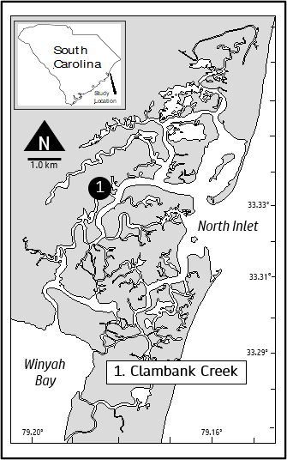

**Figure 1.** North Inlet Estuary, South Carolina and the location for water collections at Clambank Creek (lat. 33°20’02.05” N, long. 79°11’34.62” W).

.

*Nutrient Enrichment Bioassays*

Experimental nutrient addition bioassays were performed monthly from May-September 2023. Surface water (0.5 m depth) was collected using a diaphragm pump in the daytime within 2 h of peak high tide. Culture flasks (250 ml each with 35 replicates) were filled for nutrient enrichment bioassays.

There were 6 treatment groups including a control (no nutrient addition) and five nutrient additions, each with 5 replicates per bioassay (Table 1). Samples were incubated for 48 h under ambient temperature and irradiance conditions on water tables adjacent to the estuary (Lewitus et al., 1998). To prevent light inhibition, samples were covered with two layers of neutral density filters (gray fiberglass screen), reducing the irradiance to ca. 40% of solar radiation. Flasks were gently mixed 3-4 times daily during daylight hours.

For analyses, phytoplankton biomass (as chl *a* in µg l-1) responses were normalized to the control treatment to calculate percent change using the equation:

where is the biomass of the enriched group and is the mean biomass of the control group. This was calculated for total biomass as total chl *a*, as well as abundance of 6 different algal groups (i.e. cryptophytes, cyanobacteria, diatoms, dinoflagellates, green algae, and haptophytes).

*Photopigment Analysis*

Photopigments (chl *a* and accessory pigments) were analyzed to estimate phytoplankton biomass and community composition, respectively. Water (100-150 ml) was gently vacuum filtered onto glass fiber filters (Sterlitech, gf/f, 0.7 µm nominal pore size). Filters were stored at -80 ℃ until lyophilization for ca. 24 hours at -50 ℃, followed by extraction for 24 hours in 1 ml of 90% acetone and 100 µl carotenal (as synthetic carotenoid β-apo-8′-carotenal (internal standard). The extracts were filtered with a 45 µm nylon syringe filter (VWR), and 400 µl of the extract was combined with 100 µl of 1.0 M ammonium acetate. Extracts (250 µl) were injected into a Shimadzu 2050 high performance liquid chromatograph (HPLC). The stationary phase was a monomeric (Rainin Microsorb, 0.46 × 1.5 cm, 3 μm packing) and a polymeric (Vydac 201TP54, 0.46 × 25 cm, 5 μm packing) reverse-phase C18 column in series. The mobile phase consisted of an 80% methanol/20% 0.5 M ammonium acetate solvent and an 80% methanol/20% acetone solvent (Pinckney et al., 1996). Retention time and absorption spectra were compared with standards to identify pigment peaks (DHI, Denmark).

A chemotaxonomic approach based on photopigment concentrations was then used to determine the abundance of phytoplankton groups. This process used a starting matrix of photopigment:chl *a* ratios for different taxa based on presence or absence of the pigment in that phytoplankton group, with maximum and minimum constraints, all derived from literature (Hayward et al., 2023). The matrix was then “perfected” by generating many possibilities through simulated annealing, paired with alternating least squares or steepest descent algorithms to find the matrix with lowest error. The “best fit” matrix was then multiplied by photopigment concentrations determined via HPLC to calculate the abundance (as chl *a*) of each phytoplankton group. This was performed using the *phytoclass* package in R (Hayward et al., 2023).

*Nutrient Analysis*

Nutrient concentrations were measured at T0 and the end of the 48 h incubations. Composite samples were made for each treatment group by combining 50 mL from each replicate. Composites were filtered with a 0.45 um filter (Nylon VWR, cat. 76308-700) and stored at -20 ℃ until analysis. A Seal Analytical nutrient AutoAnalyzer3 was used to analyze samples for nitrate (NO3-), orthophosphate (PO4-3), ammonium (NH4+), and nitrite (NO2-) following Grasshoff et al (1999).

*Statistical Analysis*

A one-way Analysis of Variance (ANOVA) with treatment group as the factor and the percent change in total chl *a* from the control as the dependent variable was used to determine nutrient limitation status across the growing season. An REGWF test was used for *post hoc* comparisons of means. To determine nutrient limitation status for individual bioassays, we used one-way ANOVAs with treatment group as the factor and as the dependent variable. Games-Howell tests were used for *post hoc* comparisons of means. Community composition was analyzed using a randomized complete blocks design two-way MANOVA, where bioassay date was the blocking factor, taxonomic group was the main factor, and abundance of taxonomic groups were the dependent variables. Discriminant analysis was used to predict treatment group membership based on abundance of taxonomic groups. One-way ANOVAs with treatment group as the factor and the percent change in abundance from the control as the dependent variable was used to determine response of individual taxonomic groups to nutrient enrichment. REGWF tests were used for *post hoc* comparisons of means. One-way ANOVAs with treatment group as the factor and Fv/Fm as the dependent variable were performed for each of the June, July, and September bioassays. REGWF tests were used for *post hoc* comparisons of means.

**Results**

**Table 1.** Water quality parameters at Clambank Landing at the beginning time point of sample collection (rounded to closest quarter hour). Data taken from NOAA NERR SWMP. No measurements were taken 06/06/2024 due to equipment malfunctions.

|  |  |  |  |  |  |  |  |  |
| --- | --- | --- | --- | --- | --- | --- | --- | --- |
|  | Water Temperature (℃) | Specific Conductivity (mS/cm) | Salinity (psu) | Dissolved Oxygen (mg/L) | Dissolved Oxygen (percent saturation) | Depth (m) | pH | Turbidity (FNU) |
| 05/08/2024  09:30 | 21.5 | 50.9 | 33.5 | 6 | 83.1 | 1.7 | 7.8 | 14 |
| 06/06/2024 | - | - | - | - | - | - | - | - |
| 07/04/2024  10:45 | 29 | 53.67 | 35.5 | 4.5 | 71.7 | 1.74 | 7.6 | 12 |
| 09/01/2024  10:45 | 27.2 | 54.9 | 36.3 | 6.3 | 96.9 | 2.34 | 7.9 | 14 |

Conditions reflected seasonality, little differences besides temp

*Total Chl* a *Response to Nutrient Enrichment*

**Figure 2.** Total chl *a* (µg l-1) for all treatment groups in all bioassays. Error bars represent standard deviation. Values were derived from HPLC analysis.

**Figure 2.** Percent change in total chl *a* relative to the control across all bioassays. Error bars represent standard deviation. Values were derived from HPLC analysis.

All nutrient enrichments resulted in an increase in total chl *a* relative to the control (Fig. 2). The results of a one-way ANOVA (F = 6.638, n = 20, df = 4) suggested differences in percent change of biomass between nutrient enrichment groups (p = 0.003), indicative of co-limitation by N and P, with N as the primary limiting nutrient. The percent change of DIN+HP was significantly greater than HP (p = 0.0076) and LP (p = 0.0103). DIN+LP percent change in total chl *a* was also significantly greater than HP (p = 0.0103) and LP (p = 0.0225). Percent change for the DIN group did not significantly differ from any other treatment but did generate a greater percent change than the LP or HP groups (Fig. 2).

N was the primary limiting nutrient for the May bioassay (Figure A1A). Biomass increased significantly from the control in response to the DIN, HP, DIN + LP, and DIN + HP treatments, with the strongest increases in the combined nutrient treatments, followed by the DIN enrichment (Table A1). The June bioassay demonstrated serial limitation with N as the primary limiting nutrient, as the response to the combined nutrient treatments was stronger than the DIN treatment, and all N treatments induced a stronger response than P only treatments (Fig. A1B, Table A1). N was the single limiting nutrient for the July bioassay, only the DIN, DIN +LP, and DIN + HP groups showed a significant increase in biomass compared to the control, and there was no difference in biomass between the N alone and N+P treatments (Figure A1C, Table A1). In the September bioassay, N was the primary limiting nutrient (Figure A1D). All nutrient enrichments other than LP led to a significant increase in biomass compared to the control, but the DIN treatment had the strongest response (Table A1).

*Community Composition response to Nutrient Enrichment*

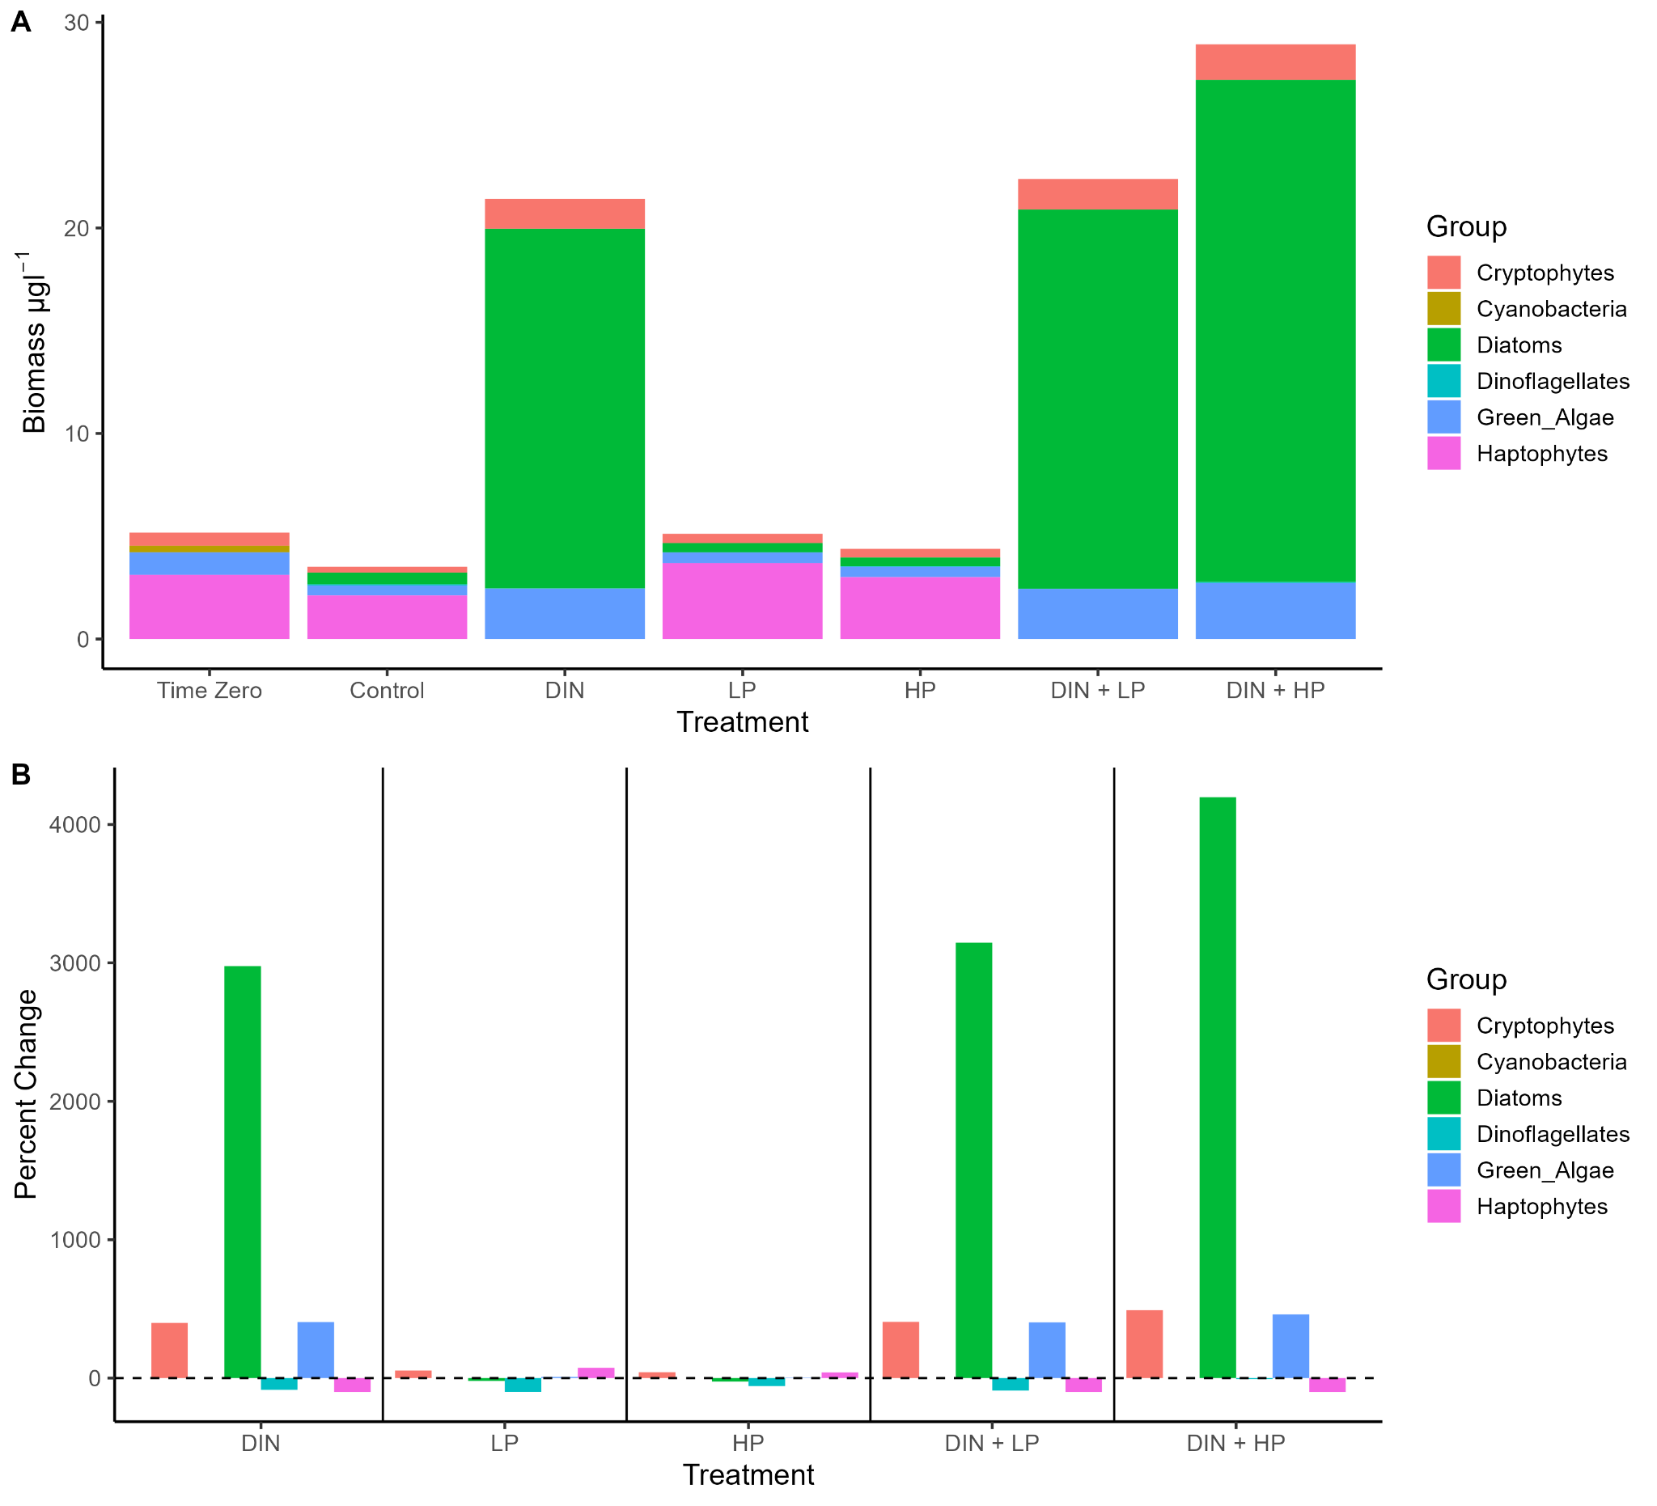

**Figure 3.** Biomass of taxonomic groups (µg chl *a* l-1) for all treatment groups in the May bioassay (A) and percent change relative to control for all taxonomic groups in the May bioassay (B). The black dashed line represents no change from control. Bars above the line represent an increase in biomass relative to the control and bars below the line represent a decrease in biomass relative to the control. Values were derived from analysis with PhytoClass software.

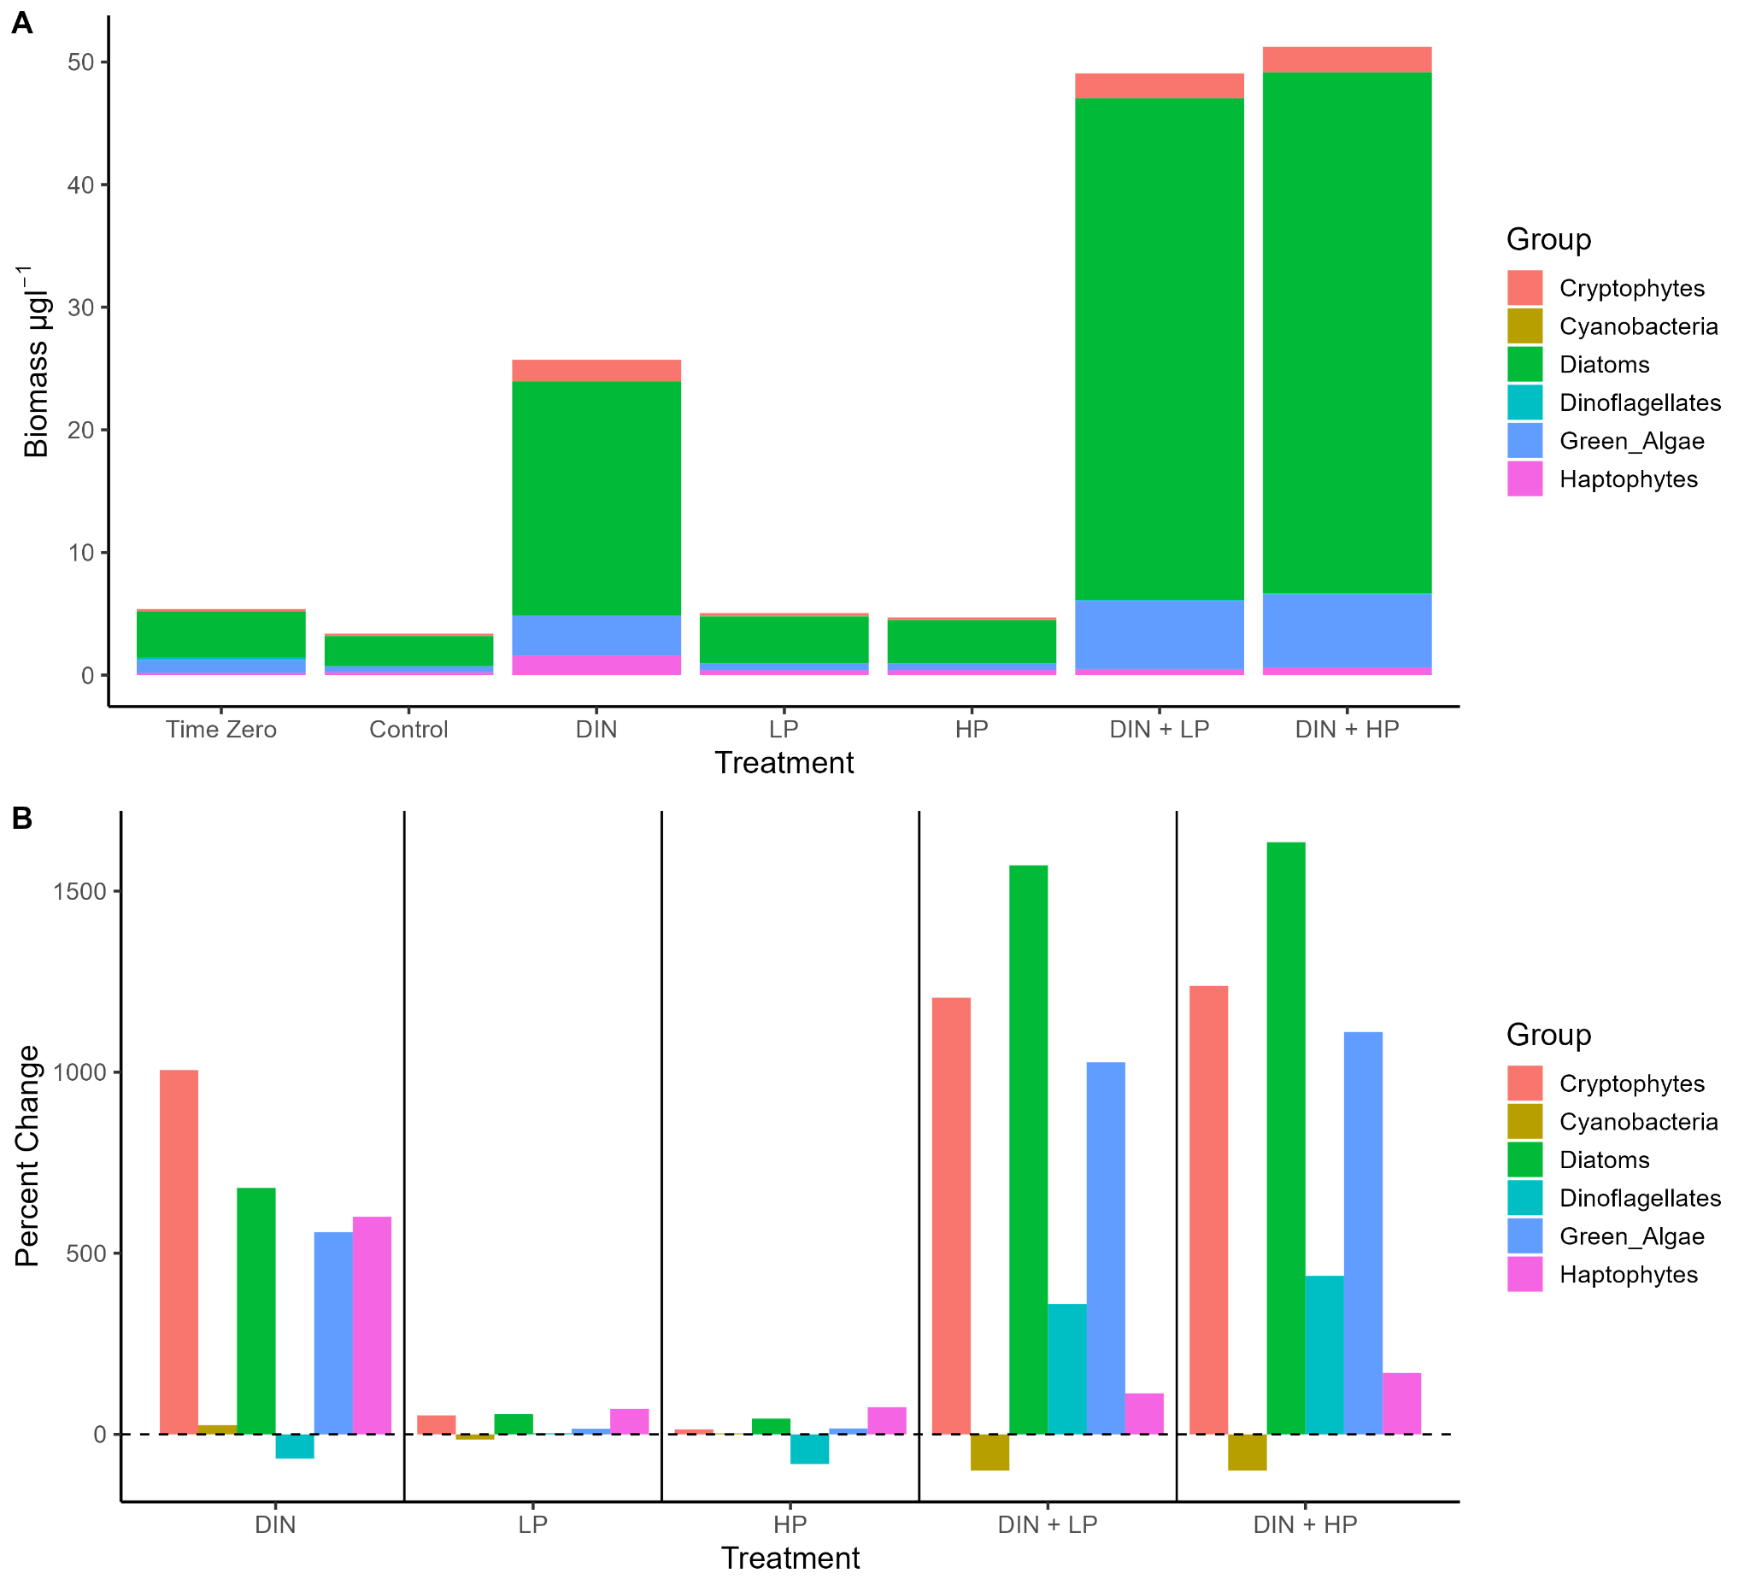

**Figure 4.** Biomass of taxonomic groups (µg chl *a* l-1) for all treatment groups in the June bioassay (A) and percent change relative to control for all taxonomic groups in the June bioassay (B). The black dashed line represents no change from control. Values above the line represent an increase in biomass relative to the control and values below the line represent a decrease in biomass relative to the control. Values were derived from analysis with PhytoClass software.

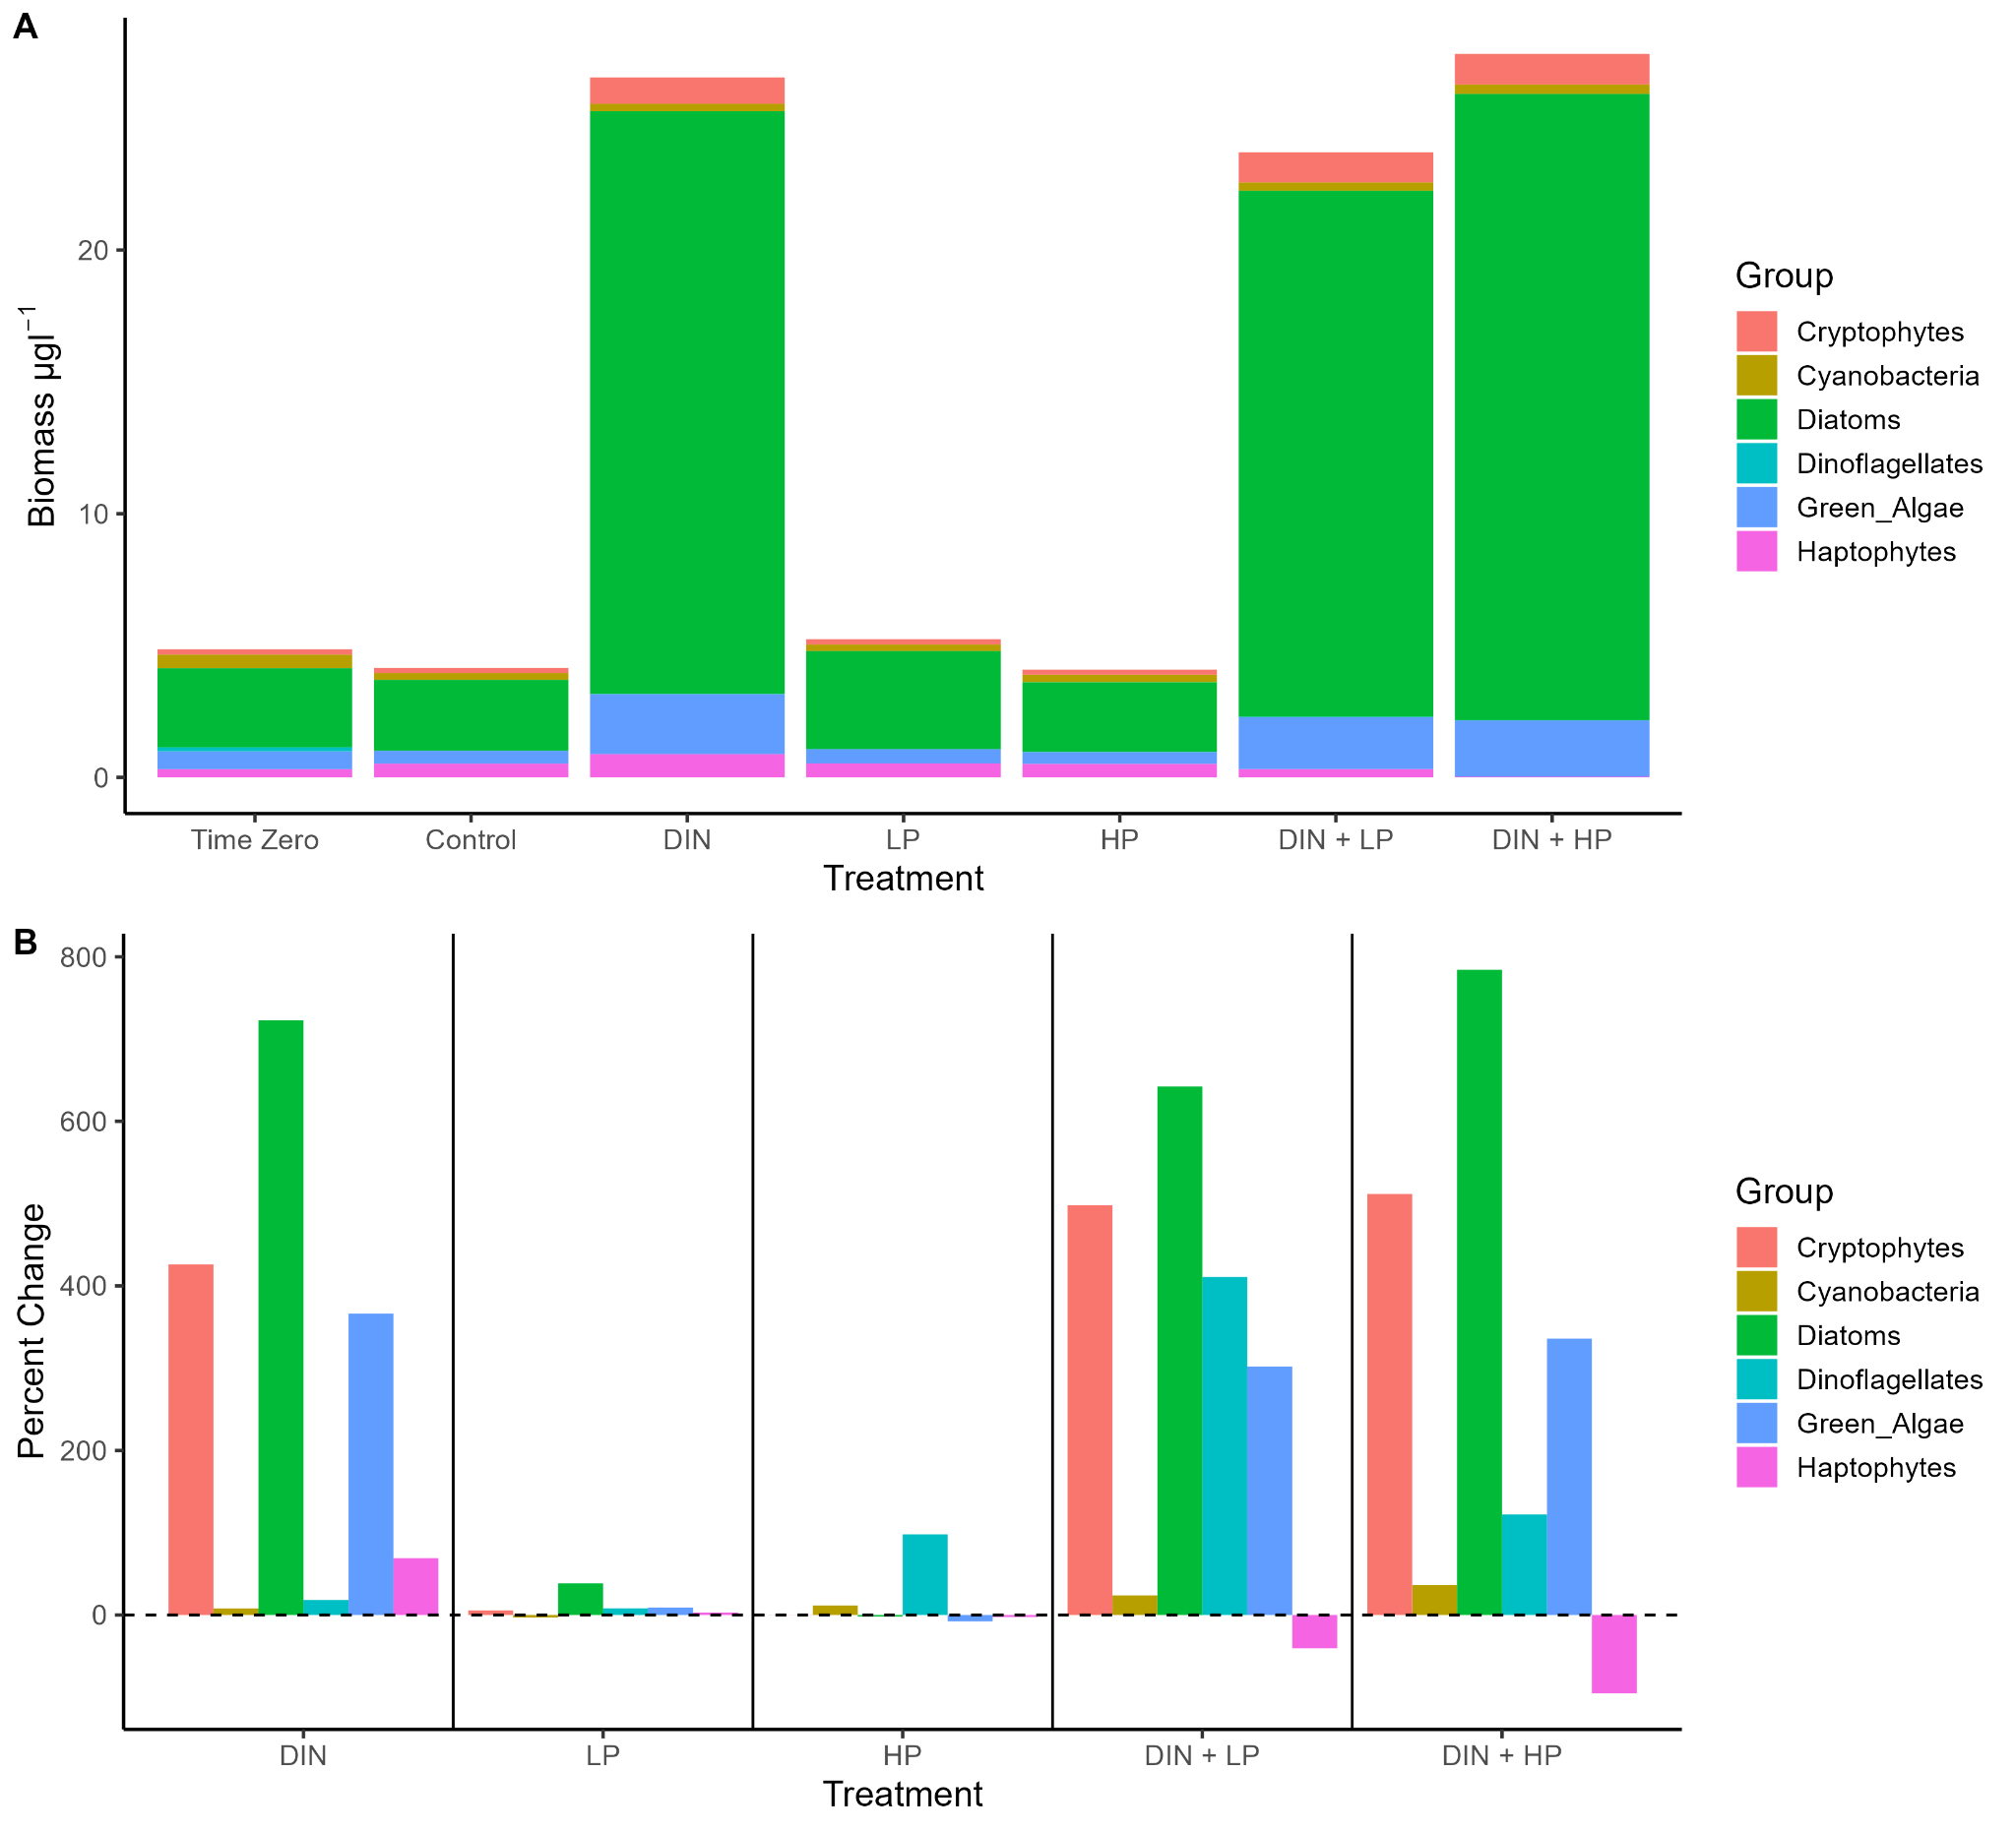

**Figure 5.** Biomass of taxonomic groups (µg chl *a* l-1) for all treatment groups in the July bioassay (A) and percent change relative to control for all taxonomic groups in the July bioassay (B). The black dashed line represents no change from control. Values above the line represent an increase in biomass relative to the control and values below the line represent a decrease in biomass relative to the control. Values were derived from analysis with PhytoClass software.

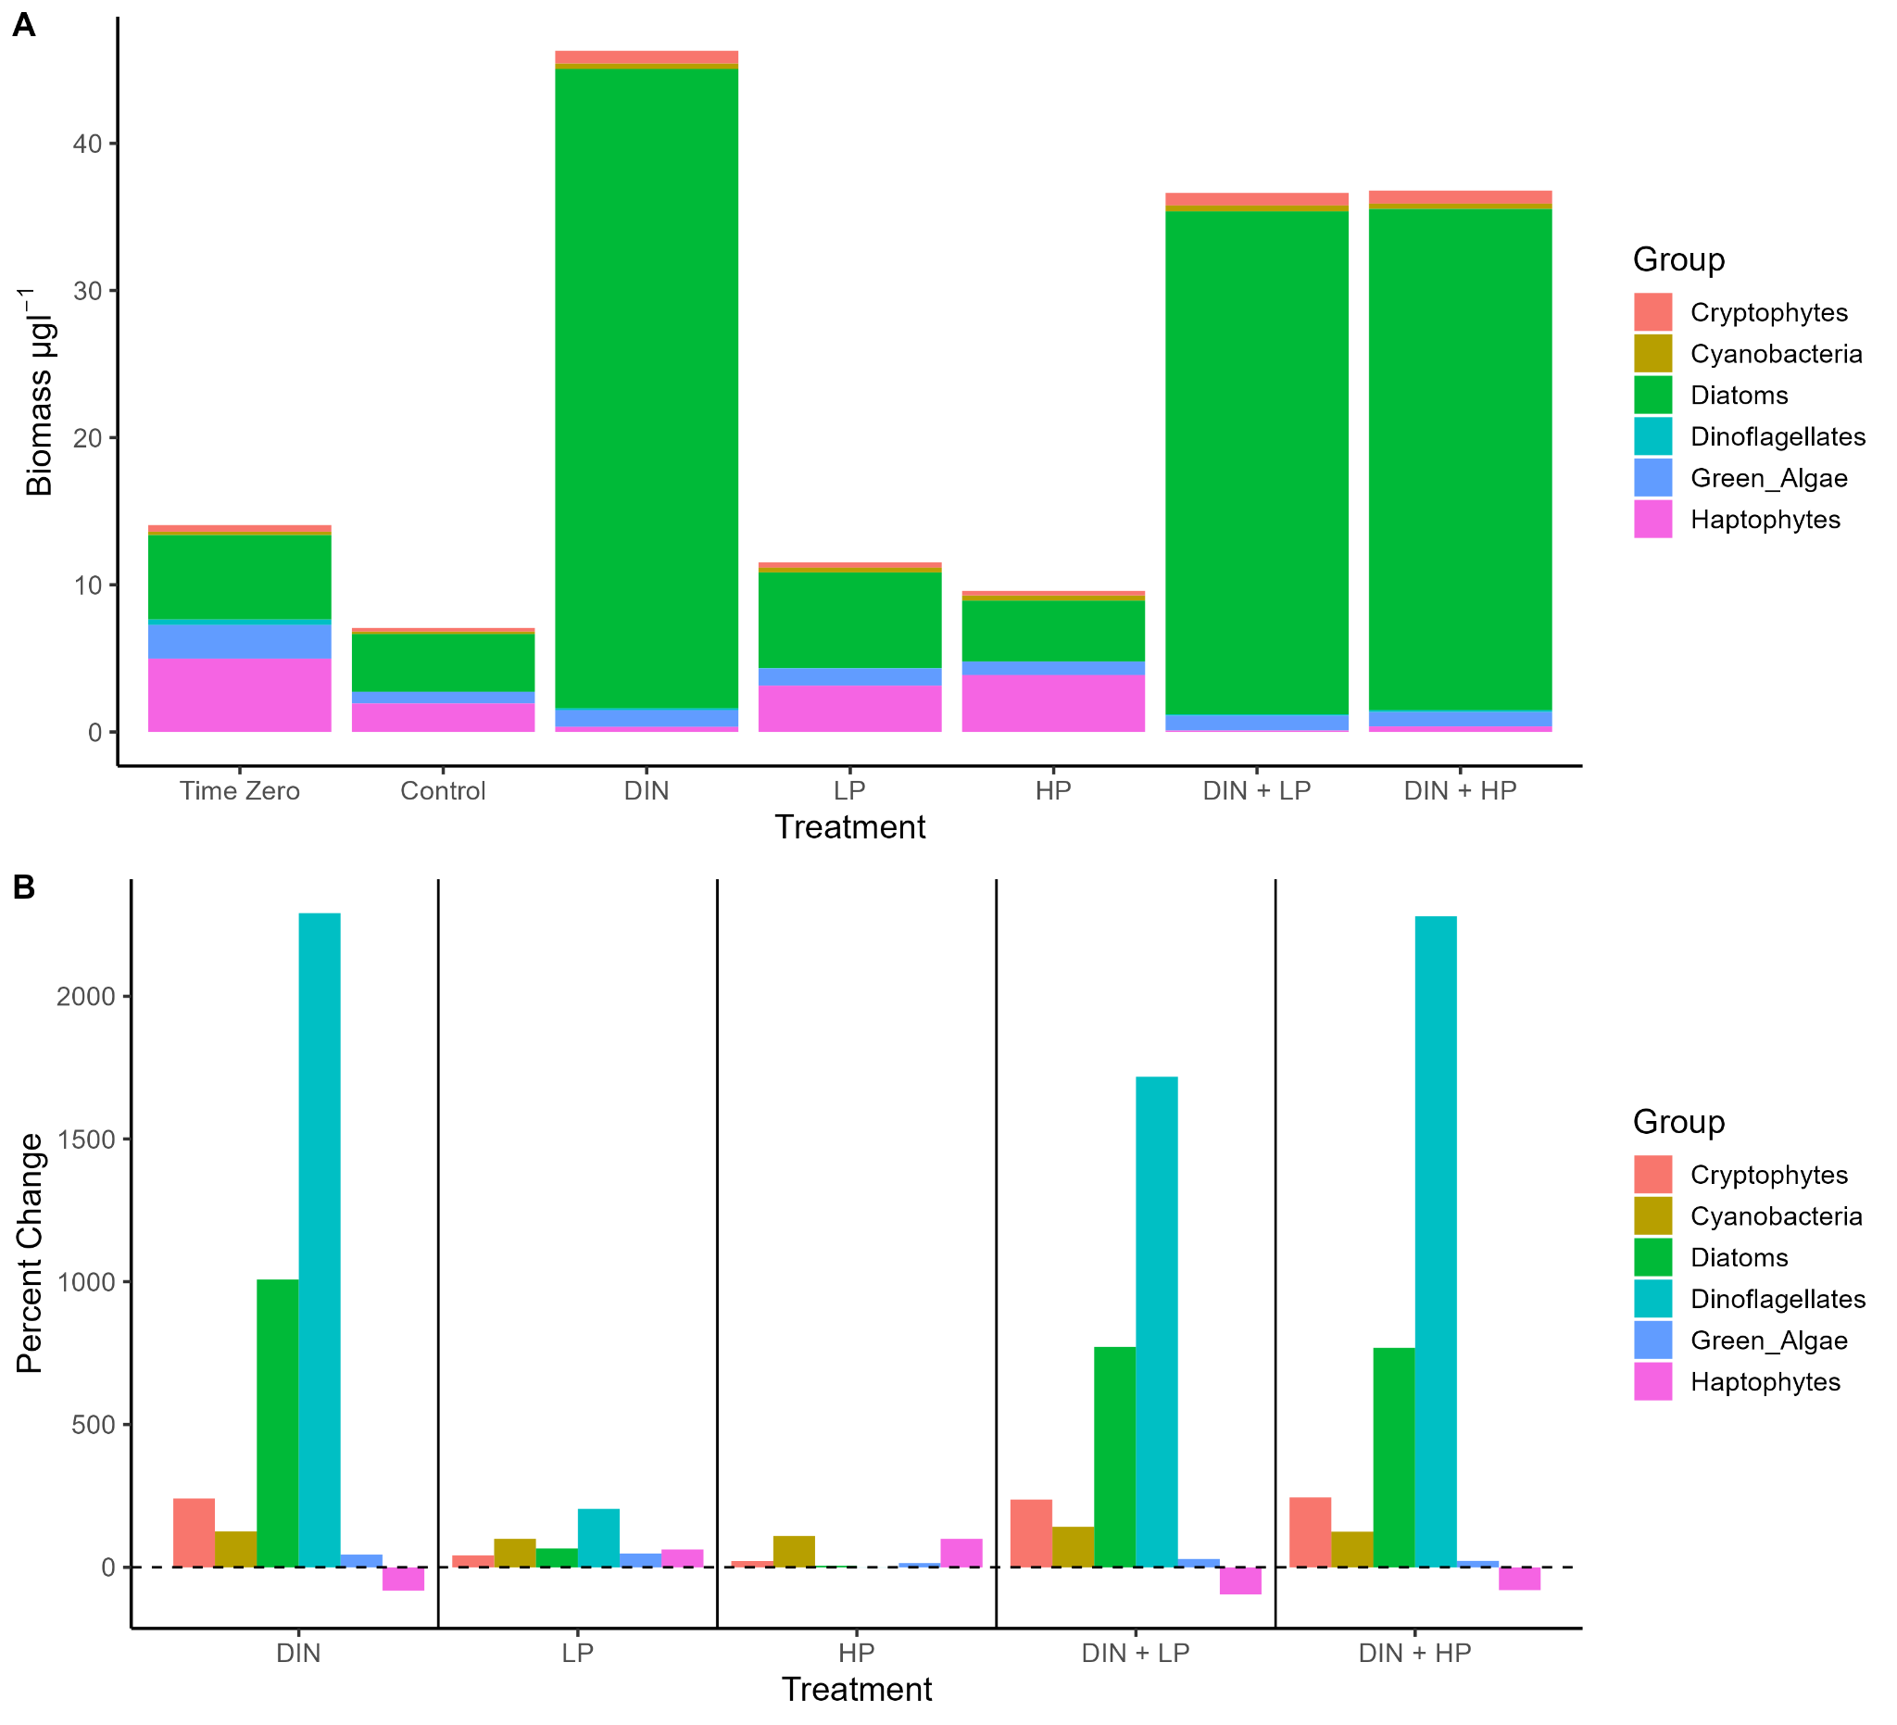

**Figure 6.** Biomass of taxonomic groups (µg chl *a* l-1) for all treatment groups in the September bioassay (A) and percent change relative to control for all taxonomic groups in the September bioassay (B). The black dashed line represents no change from control. Values above the line represent an increase in biomass relative to the control and values below the line represent a decrease in biomass relative to the control. Values were derived from analysis with PhytoClass software.

Diatoms comprised the majority of the phytoplankton community across nearly all treatment groups for the June, July, and September bioassays, with the exception of the time zero (40.82%) and HP (43.18%) groups in the September bioassay (Figures 4A, 5A, 6A). Diatoms were also dominant in the May bioassay, but haptophytes composed the largest proportion of the community at time zero (60.29%), as well as in the control (60.26%) and LP (72.08%) and HP (68.68%) treatments. However, haptophytes declined to undetected (DIN and DIN + LP) or very low levels (-99.97% relative to control, DIN + HP) in some treatments in May (Figure 4A). Cyanobacteria were detected at time zero in the May bioassay but were not detected in the control or any treatment groups in May, nor were they detected in the June DIN+LP or DIN+HP groups (Fig. 3). There was no difference in percent change in abundance relative to the control between treatment groups for any taxonomic group (Figures A3-8).

MANOVA results suggested that community composition changed with nutrient enrichment (Pillai’s trace = 1.6886, p < 0.001) and there was a significant blocking effect (i.e., bioassay date) (Pillai’s trace = 1.7495, p < 0.001). Discriminant analysis also indicated differences in community composition between nutrient enrichment treatments, grouping together all DIN enrichments (DIN, DIN+LP, and DIN+HP) separately from all other groups (time zero, control, LP, and HP (Fig. 4). Function 2 also separated initial community composition from the control and nutrient enriched groups (Fig. 4).

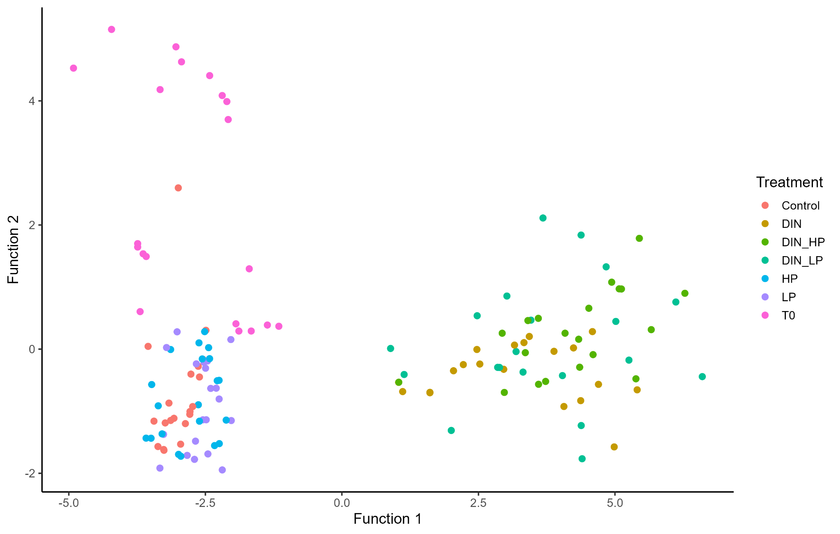

**Figure 7.** Discriminant analysis plot for the relative abundance of taxonomic groups in the phytoplankton community. Points represent replicates from all bioassays. Function 1 explained 89% of between-class variance and Function 2 explained 10% of between-class variance. Percent classified correctly was 50.7%.

*Nutrients*

For all bioassays, PO4 concentrations were highest in the HP or DIN+HP then LP or DIN+LP treatments (Table 2). NO3 concentrations were at or near 0 µM for all but the DIN treatments in the May, June, and July bioassays and were highest in September (Table 2). NH4 concentrations were typically higher in N-amended groups, but there were no clear patterns. NO2- was consistently < 1 µM throughout the summer and between treatments (Table 2).

**Table 2.** Inorganic nutrient concentrations at time zero and post-incubation (72h) for each treatment group. Values represent the mean of 4 subsamples taken from the composite sample. DIN:DIP was calculated as (NO3+NH4+NO2)/(PO4). Dashes represent missing data or DIN:DIP ratios that could not be calculated because of undetectable PO4 concentrations.

|  |  |  |  |  |  |  |
| --- | --- | --- | --- | --- | --- | --- |
|  | **NO3- (µM)** | **PO4+3(µM)** | **NH4+ (µM)** | **NO2- (µM)** | **DIN:DIP** | **Uptake Rate** |
| **May**  Time Zero  Control  DIN  LP  HP  DIN+LP  DIN+HP | 0.625  0.178  1.12  0.161  0.286  0  0.125 | 0.194  0.0969  0.121  2.67  15.4  1.21  12.3 | 0.178  1.41  15.4  14.5  8.69  7.57  1.3 | 0.601  0.600  0.676  0.796  0.762  0.625  0.637 | 7.24  22.6  142  5.79  0.632  6.77  0.167 |  |
| **June**  Time Zero  Control  DIN  LP  HP  DIN+LP  DIN+HP | 0  0.303  7.44  0.393  0.946  0.0178  0.714 | 0  0  0  2.44  16.0  1.86  14.5 | 2.78  1.14  2.19  1.71  0  0  0 | 0.666  0.633  0.712  0.637  0.633  0.646  0.662 | -  -  -  1.12  0.0987  0.357  0.0949 |  |
| **July**  Time Zero  Control  DIN  LP  HP  DIN+LP  DIN+HP | 0  2.57  0  0  0  0  0 | 0  0.541  0  4.04  18.1  2.12  14.9 | -  -  -  -  -  -  - | -  -  -  -  -  -  - | -  4.75  -  0  0  0  0 |  |
| **September**  Time Zero  Control  DIN  LP  HP  DIN+LP  DIN+HP | 1.20  1.86  1.64  1.61  1.96  1.73  1.86 | 0  0  0  1.28  12.2  0  14.1 | 3.3  7.49  1.39  0.428  2.19  1.46  7.24 | 0.344  0.293  0.332  0.291  0.357  0.364  0.393 | -  -  -  1.82  0.369  -  0.673 |  |

**Discussion**

Nutrient limitation category definitions were adapted from Kolzau et al. (2014): Single nutrient limitation occurs when there is an increase in biomass in response to one of the single nutrient additions and it is no different from the combined nutrient treatment. Serial limitation occurs when there is an increase in biomass in response to only one nutrient addition, but the response of the combined nutrient treatment is larger than the single nutrient response. Independent co-limitation occurs when biomass increases for both single nutrient additions and the combined nutrient treatment has a larger response. In this case, the single nutrient addition with the larger response would be the primary limiting nutrient. Finally, if there is no increase in biomass for any nutrient addition, there is no nutrient limitation.

Our hypothesis was that P would be the primary limiting nutrient for phytoplankton biomass in NIE, meaning that the largest response would be in the LP and HP conditions. This was not supported; rather, evidence suggests that N was the single or primary limiting nutrient during the 2023 growing season despite the high N:P ratios (Fig. 2). This is in line with previous investigations that suggested N limitation or co-limitation in NIE (Bell et al., 2018; J. Pinckney, personal communication, November 19, 2022). N limitation in estuaries is a very well documented occurrence, not only historically in NIE, but in other systems as well (Gobler et al., 2006; Pederson, 1995; Cira et al., 2016). Additionally, cyanobacteria were a small contributor to the phytoplankton community in this study (Figs. 3-6). The relative absence of cyanobacteria suggests one less inorganic N source in North Inlet, which may contribute to primary N-limitation in the system.

Phytoplankton have a few strategies for surviving through low P concentrations or high N:P ratios, and these are possible being employed by phytoplankton in NI, “hiding” evidence of P-limitation related to low P concentrations and high DIN:DIP ratios (Glibert & Burkholder, 2011; Glibert, 2017). Some phytoplankton can use alternatives for P in molecules such as lipids, reducing their P requirement (Van Mooy et al., 2009). Others can modulate P demands via reductions in the concentrations of P-rich cellular components including nucleic acids, RNA in particular, and more minor contributors to the P pool such as ATP and glucose phosphate coenzymes (Bertilsson et al., 2003; Geider & La Roche, 2002). Many phytoplankton use high affinity P-transport systems to enhance their ability to assimilate P in environments with low concentrations (Harke et al., 2009; Cáceres et al., 2019) Some are capable of using organic P via the hydrolyzation of refractory phosphonates and phosphomonoesters using enzymes such as phosphonatases and alkaline phosphatases (Dyhrman et al., 2006; Dyhrman & Ruttenberg, 2006; Harke et al., 2009). Phosphomonoesters and phosphodiesters are particularly prevalent in the DOP pool in NI, which comprises a significant portion of the P pool during some parts of the year (Bell et al., 2018, 2020). Many phytoplankton can also store nutrients (including P, often as organic P compounds) in internal pools during times of plenty, for later use when the nutrient is scarce (Geider & La Roche, 2002; Anderson et al., 1991; Lin et al., 2016). These strategies are often by cyanobacteria and dinoflagellates (Glibert & Burkholder, 2011). NIE is dominated by diatoms, as demonstrated in this study, so these strategies may also be similarly employed by diatoms. More work should be done to evaluate the extent to which phytoplankton are relying on DOP as a source of inorganic P to support primary production in NIE. Several other studies have found evidence for primary N limitation or N and P co-limitation in systems with high N:P ratios indicative of P limitation which was attributed to nutrient conversion and remineralization as well as stoichiometric plasticity in phytoplankton (Moore et al., 2008; Thingstad et al., 2005).

*Insert community composition info (planning on discussion implications for trophodynamics here as well).*

When nutrient loading is sufficient and absolute concentrations are high, there is potential for the system to shift from nutrient-dominated competition to competition based on light availability (Brauer et al., 2012). For example, light limitation was shown in the Tagus estuary in Portugal, which has nutrient concentrations high enough to sustain growth, but still sees low phytoplankton biomass results from insufficient light related to turbidity (Gameiro et al., 2011). This is a particularly viable regime shift in environments like estuaries where turbidity can be high from riverine or tidally driven sediment input and resuspension, increasing the likelihood of light limitation (Cloern, 1987). This has been demonstrated in the Changjiang Estuary, where there was temporal variation in the primary limiting factor being either light or nutrients, depending on seasonal nutrient concentrations and turbidity (Zhu et al., 2009). The increase in nutrient loading over the last several decades may have pushed NIE further towards light availability as the primary control over phytoplankton growth. Future studies should investigate the roles of light and nutrient limitation in the regulation of phytoplankton growth and biomass in NIE.

This study only examined the nutrient limitation status of phytoplankton during one season, the summer of 2023. Nutrient loading changes seasonally, so it is possible that nutrient limitation status may exhibit seasonality as well. Seasonal transitions between primary P-, primary N-, and N and P co-limitations have been demonstrated in several other systems including the Chesapeake Bay, Neuse River Estuary, Bothnian Sea, and Archipelago Sea (Fisher et al., 1992; Rudek et al., 1991; Tamminen & Anderson, 2007). There is also evidence that estuaries can transition between light and nutrient limitation seasonally depending on temporal cycles of turbidity and nutrient concentrations, like the Delaware Bay that shifted between winter-time light-limitation and spring P-limitation (Pennock & Sharp, 1994). Seasonal variation in nutrient concentrations and stoichiometry in NIE has been demonstrated by several groups. For instance, Buzzelli et al. (2004) found peak phosphate and ammonium concentrations in the summer and peak DON concentrations in late summer at Oyster Landing. They found no significant seasonal patterns for nitrate/nitrite concentrations but noted that summer nitrate concentrations were the lowest (Buzzelli et al., 2004). More recently at the same site, Bell et al. (2018) found DIN and soluble reactive phosphorus (SRP) maxima in the summer and minima in the winter, with DON and DOP spring and summer maxima and fall minima. They also found a DIN:SRP maximum in the spring and minimum in the fall and DON:DOP maxima in winter with minima in the summer (Bell et al., 2018). It is possible that we missed temporal patterns in nutrient limitation, so future nutrient enrichment bioassays should be performed year-round to better understand how phytoplankton biomass is impacted across different seasons.

As primary producers and the base of marine food webs, phytoplankton play a critical role in maintaining ecosystem health and functionality. They also facilitate the cycling of nutrients, so understanding the interactions between nutrients and phytoplankton growth has broad implications for evaluating the state of these systems, especially considering changing environmental conditions. Given their position as the interface between ocean, river, and terrestrial systems, estuaries provide critical habitat and ecosystem services, as well as economic and recreational services. However, this also means they face a myriad of overlapping climate change related challenges, from pollution to ocean warming, and many more (Scavia et al., 2002). Even relatively undeveloped watersheds, such as that of North Inlet, are facing increasing levels of environmental changes like sea level rise and eutrophication (Krask et al., 2022; Dunn et al., 2023). Knowledge of the consequences of climate change and anthropogenic influence on biota in these systems is vital in determining best management practices to mitigate any negative effects that have potential ecosystem-wide impacts.

Despite high DIN:DIP ratios in North Inlet, N was the primary limiting nutrient for the 2023 growing season. Insert info about changes in community composition here. While the Redfield ratio is often used to infer nutrient limitation status, high inter- and intraspecific variability and plasticity in the nutrient requirements of phytoplankton can lead to groups and systems straying from 16 as the transition from limitation by one nutrient to the other. Rather, a more accurate critical point marking a shift from N- to P-limitation may actually be higher than the Redfield ratio, somewhere in the range of 20-50 (Geider & La Roche, 2002). Results from this study support a higher breaking point for nutrient limitation and suggest that molar ratios and stoichiometry should be used carefully when analyzing nutrient limitation. They may not always be reflective of the true limitation status within the system (Domingues et al., 2023). Rather, ratios should be used in conjunction with experimental methods, such as enrichment bioassays, that provide more context and a potentially more accurate evaluation of nutrient limitation.

**References**

Allen, D.M., W.B. Allen, R.F. Feller, and J.S. Plunket, editors. 2014. Site Profile of the North Inlet – Winyah Bay National Estuarine Research Reserve. North Inlet – Winyah Bay National Estuarine Research Reserve. Georgetown, S.C. 432 pp.

Alvarez-Fernandez, S., Lindeboom, H., & Meesters, E. (2012). Temporal changes in plankton of the North Sea: community shifts and environmental drivers. *Marine Ecology Progress Series*, *462*, 21-38. <https://doi.org/10.3354/meps09817>

Anderson, T., Schartau, A.K.L., & Paasche, E. (1991). Quantifying external and internal nitrogen and phosphorus pools, as well as nitrogen and phosphorus supplied through remineralization, in coastal marine plankton by means of a dilution technique. *Marine Ecology Progress Series*, *69*, 67-80.

Beardall, J., Young, E., & Roberts, S. (2001). Approaches for determining phytoplankton nutrient limitation. *Aquatic Sciences*, *63*, 44-69. <https://doi.org/10.1007/PL00001344>

Bell, D.W., Denham, S., Smith, E.M., & Benitez-Nelson, C.R. (2018). Temporal Variability in Ecological Stoichiometry and Material Exchange in a Tidally Dominated Estuary (North Inlet, South Carolina) and the Impact on Community Nutrient Status. *Estuaries and Coasts*, *41*, 2223-2239.<https://doi.org/10.1007/s12237-018-0430-7>

Bell, D.W., Denham, S., Smith, E.M., & Benitez-Nelson, C.R. (2018). Temporal Variability in Ecological Stoichiometry and Material Exchanges in a Tidally Dominated Estuary (North Inlet, South Carolina) and the Impact on Community Nutrient Status. *Estuaries and Coasts*, *41*, 2223-2239. <https://doi.org/10.1007/s12237-018-0430-7>

Bell, D.W., Pellechia, P.J., Ingall, E.D., & Benitez-Nelson, C.R. (2020). Resolving marine dissolved organic phosphorus (DOP) composition in a coastal estuary. *Limnology and Oceanography*, *65*, 2787-2799. [https://doi.org/](https://doi.org/10.1007/s12237-018-0430-7)10.1002/lno.11552

Bertilsson, S., Berglund, O., Karl, D.M., & Chisholm, S.W. (20030. Elemental composition of marine *Prochlorococcus* and *Synechococcus*: Implications for the ecological stoichiometry of the sea. *Limnology and Oceanography*, *48*(5), 1721-1731.

Bi, R., Cao, Z., Ismar-Rebitz, S.M.H., Sommer, U., Zhang, H., Ding, Y., & Zhao, M. (2021). Responses of Marine Diatom-Dinoflagellate Competition to Multiple Environmental Drivers: Abundance, Elemental and Biochemical Aspects. *Frontiers in Microbiology*, *12*, 731786. <https://doi.org/10.3389/fmicb.2021.731786>

Brauer, V.S., Stomp, M., & Huisman, J. (2012). The Nutrient-Load Hypothesis: Patterns of Resources Limitation and Community Structure Driven by Competition for Nutrients and Light. *The American Naturalist*, *179*(6), 721-740. <https://doi.org/10.1086/665650>

Breitburg, D.L., Sanders, J.G., Gilmour, C.C., Hatfield, C.A., Osman, R.W., Riedle, G.F., Seitzinger, S.P., & Sellner, K.G. (1999). Variability in responses to nutrient and trace elements, and transmission of stressor effects through an estuarine food web. *Limnology and Oceanography*, *44*(3, part 2), 837-863.

Cáceres, C., Spatharis, S., Kaiserli, E., Smeti, A., Flowers, H., & Bonachela, J.A. (2019). Temporal phosphate gradients reveal diverse acclimation responses in phytoplankton phosphate uptake. *ISME Journal*, *13*, 2834-2845. <https://doi.org/10.1038/s41396-019-0473-1>

Cira, E.K., Paerl, H.W., & Wetz, M.S. (2016). Effects of Nitrogen Availability and Form on Phytoplankton Growth in a Eutrophied Estuary (Neuse River Estuary, NC, USA). *PLoS ONE*, *11*(8), e0160663. <https://doi.org/10.1371/journal.pone.0160663>.

Cloern, J.E. (1987). Turbidity as a control on phytoplankton biomass and productivity in estuaries. *Continental Shelf Research*, *7*(11/12), 1367-1381. <https://doi.org/10.1016/0278-4343(87)90042-2>

Domingues, R.B., Nogueira, P., & Barbosa, A.B. (2023). Co-limitation of Phytoplankton by N and P in a Shallow Coastal Lagoon (Ria Formosa): Implications for Eutrophication Evaluation. *Estuaries and Coasts*, *46*, 1557-1572. <https://doi.org/10.1007/s12237-023-01230-w>

Dunn, R.P., Krask, J.L., Pinckney, J.L., & Smith, E.M. (2023). Contrasting trends in water quality between adjacent ocean- and river-dominated estuaries: Evidence for marsh porewaters as a source of nutrient enrichment? *Limnology & Oceanography*, *68*(9), 2040-2058. <https://doi.org/10.1002/lno.12405>

Dyhrman, S.T., Chappel, P.D., Haley, S.Y., Moffett, J.W., Orchard, E.D., Waterbury, J.B., & Webb, E.A. (2006) Phosphonate utilization by the globally important marine diazotroph *Trichodesmium*. *Nature*, *439*, 68-71. <https://doi.org/10.1038/nature04203>

Dyhrman, S.T., Ruttenberg, K.C. (2006). Presence and regulation of alkaline phosphatase activity in eukaryotic phytoplankton from the coastal ocean: Implications for dissolved organic phosphorus remineralization. *Limnology and Oceanography*, *5*(3), 1381-1390. <https://doi.org/10.4319/lo.2006.51.3.1381>

D’Elia, C.F., Sanders, J.G., & Boynton, W.R. (1986). Nutrient Enrichment Studies in a Coastal Plain Estuary: Phytoplankton Growth in Large-Scale, Continuous Cultures. *Canadian Journal of Fisheries and Aquatic Sciences*, *43*(2), 397-406.<https://doi.org/10.1139/f86-050>

Estrada, M., Alcaraz, M., & Marrasé, C. (1987). Effects of turbulence on the composition of phytoplankton assemblages in marine microcosms. *Marine Ecology Progress Series*, *38*, 267-281.

Finkel, Z.V., Beardall, J., Flynn, K.J., Quigg, A., Rees, T.A.V., & Raven, J.A. (2010). Phytoplankton in a changing world: cell size and elemental stoichiometry. *Journal of Plankton Research*, *32*(1), 119-137.

Fisher, T.R., Peele, E.R., Ammerman, J.W., & Harding, L.W. (1992). Nutrient limitation of phytoplankton in Chesapeake Bay. *Marine Ecology Progress Series*, *82*(1), 51-63.

Gameiro, C., Zwolinski, J., & Brotas, V. (2011). Light control on phytoplankton production in a shallow and turbid estuarine system. *Hydrobiologia*, *669*, 249-263. <https://doi.org/10.1007/s10750-011-0695-3>

Geider, R.J. & La Roche, J. (2002). Redfield revisited: variability of C:N:P in marine microalgae and its biochemical basis. *European Journal of Phycology*, *37*, 1-17. <https://doi.org/10.1017/S0967026201003456>

Gilbert, P.M., Fullerton, D., Burkholder, J.M., Cornwell, J.C., & Kana, T.M., (2011). Ecological Stoichiometry, Biogeochemical Cycling, Invasive Species, and Aquatic Food Webs: San Francisco Estuary and Comparative Systems. *Reviews in Fisheries Science*, *19*(4), 358-417.<https://doi.org/10.1080/10641262.2011.611916>

Glibert, P.M., Fullerton, D., Burkholder, J.M., Cornwell, J.C., & Kana, T.M. (2011). Ecological Stoichiometry, Biogeochemical Cycling, Invasive Species, and Aquatic Food Webs: San Francisco Estuary and Comparative Systems. *Reviews in Fisheries Science*, *19*(4), 358-417. <https://doi.org/10.1080/10641262.2011.611916>

Glibert, P.M. (2017). Eutrophication, harmful algae and biodiversity – Challenging paradigms in a world of complex nutrient changes. *Marine Pollution Bulletin*, *124*(2), 591-606. <https://doi.org/10.1016/j.marpolbul.2014.04.027>

Gobler, C.J., Buck, N.J., Sieracki, M.E., & Sañudo-Wilhelmy, S.A. (2006). Nitrogen and silicon limitation of phytoplankton communities across an urban estuary: The East River-Long Island Sound System. *Estuarine, Coastal and Shelf Science*, *68*, 127-138. <https://doi.org/10.1016/j.ecss.2006.02.001>

Grasshoff, K., Kremling, K. & Ehrhardt, M. (Eds.). (1999). Methods of Seawater Analysis (3rd ed.). Wiley.

Harke, M.J., Berry, D.L., Ammerman, J.W., & Gobler, C.H. (2012). Molecular response of the bloom-forming cyanobacterium *Microcystis aeruginosa*, to phosphorus limitation. *Microbial Ecology*, *63*, 188-189. <https://doi.org/10.1007/s00248-011-9894-8>

Harrison, P.J., Hu, H.M., Yang, Y.P., & Lu, X. (1990). Phosphate limitation in estuarine and coastal waters of China. *Journal of Experimental Marine Biology and Ecology*, *140*(1-2), 79-87. <https://doi.org/10.1016/0022-0981(90)90083-O>

Hayward, A., Pinkerton, M.H., & Gutierrez-Rodriguez, A. (2023). *phytoclass*: A pigment-based chemotaxonomic method to determine the biomass of phytoplankton classes. *Limnology and Oceanography: Methods*, *21*(4), 220-241. <https://doi.org/10.1002/lom3.10541>

Hecky, R.E., & Kilham, P. (1988). Nutrient limitation of phytoplankton in freshwater and marine environments: A review of recent evidence on the effects of enrichment. *Limnology and Oceanography*, *33*(4, part 2). 796-822.

Heil, C.A., Revilla, M., Gilbert., P.M., & Murasko, S. (2007). Nutrient quality drives differential phytoplankton community composition on the southwest Florida shelf. *Limnology and Oceanography*, *52*(3), 1067-1078.<https://doi.org/10.4319/lo.2007.52.3.1067>

Hillebrand, H., Steinert, G., Boersma, M., Malzahn, A., Meunier, C.L., Plum, C., Ptacnik, R. (2013). Goldman revisited: Faster-growing phytoplankton has lower N:P and lower stoichiometric flexibility. *Limnology and Oceanography*, *58*(6), 2076-2088. <https://doi.org/10.4319/lo.2013.58.6.2076>

Howarth, R., Chan, F., Conley, D.J., Garner, J., Doney, S.C., Marino, R., & Billen, G. (2011). Coupled biogeochemical cycles: eutrophication and hypoxia in temperate estuaries and coastal marine ecosystems. *Frontiers in Ecology and the Environment*, *9*(1), 18-26.<https://doi.org/10.1890/100008>

Howarth, R.E., & Michaels, A.F. (2000). The measurement of primary production in aquatic ecosystems. In O. Sala, R. Jackson, H. Mooney, & R. W. Howarth (Eds.), *Methods in ecosystem science* (pp. 72-85). Springer. https://doi.org/10.1007/978-1-4612-1224-9_6

Howarth, R.W. (1988). Nutrient Limitation of Net Primary Production in Marine Ecosystems. *Annual Review of Ecology and Systematics*, *19*, 89-110.<https://www.jstor.org/stable/2097149>

Howarth, R.W. & Marino, R. (2006). Nitrogen as the limiting nutrient for eutrophication in coastal marine ecosystems: Evolving views over three decades. *Limnology and Oceanography*, *51*(1, part 2), 364-376.

Howarth, R.W. & Marino, R. (2006). Nitrogen as the limiting nutrient for eutrophication in coastal marine ecosystems: Evolving views over three decades. *Limnology and Oceanography*, *51*(1, part 2), 364-376.

Jones, R.H., & Flynn, K.J. (2005). Nutritional Status and Diet Composition Affect the Value of Diatoms as Copepod Prey. *Science*, *307*(5714), 1457-1459. <https://doi.org/10.1126/science.110776>

Kolzau, S., Wiedner, C., Rücker, J., Köhler, J., Köhler, A., & Dolman, A. (2014). Seasonal Patterns of Nitrogen and Phosphorus Limitation in Four German Lakes and the Predictability of Limitation Status from Ambient Nutrient Concentrations. *PloS ONE*, *9*(4), e96065.<https://doi.org/10.1371/journal.pone.0096065>

Krask, J.L., Buck, T.L., Dunn, R.P., & Smith, E.M. (2022). Increasing tidal inundation corresponds to rising porewater nutrient concentrations in a southeastern U.S. salt marsh. *PloS ONE, 17*(11).<https://doi.org/10.1371/journal.pone.0278215>

Krom, M.D., Kress, N., Brenner, S., & Gordon, L. I. (1991). Phosphorus limitation of primary productivity in the eastern Mediterranean Sea. *Limnology and Oceanography*, *36*, 424–432.

Lewitus, A.J., Koepfler, E.T., & Morris, J.T. (1998). Seasonal variation in the regulation of phytoplankton by nitrogen and grazing in a salt-marsh estuary. *Limnology and Oceanography*, *43*(4), 636-646.<https://doi.org/10.4319/lo.1998.43.4.0636>

Lin, A., Litaker, R.W.., & Sunda, W.G. (2016). Phosphorus Physiological Ecology and Molecular Mechanisms in Marine Phytoplankton. *Journal of Phycology*, *52*. 10-36. <https://doi.org/10.1111/jpy.1236510>

Lind, P.R. & Jeyasingh, P.D. (2015). Genotypic differences in phosphorus use physiology in producers (*Chlamydomonas reinhardtii*) and consumers (*Daphnia pulex*) interacts to alter primary and secondary production. *Evolutionary Ecology*, *29*, 551-563. <https://doi.org/10.1007/s10682-015-9760-0>

Litchman, E., Klausmeier, C.A., Miller, J.R., Schofield, & Falkowski, P.G. (2006). Multi-nutrient, multi-group model of present and future oceanic phytoplankton communities. *Biogeosciences*, *3*(4), 585-606.<https://doi.org/10.5194/bg-3-585-2006>

Litchman, E. & Klausmeier, C.A. (2008). Trait-Based Community Ecology of Phytoplankton. *Annual Review of Ecology, Evolution, and Systematics*, *39*, 615-639. [https://jstor.org/stable/30245179](http://jstor.org/stable/30245179)

Mackey, K.R.M., Labiosa, R.G., Calhoun, M., Street, J.H., Post, A.F., & Paytan, A. (2007). Phosphorus availability, phytoplankton community dynamics, and taxon-specific phosphorus status in the Gulf of Aqaba, Red Sea. *Limnology and Oceanography*, *52*(2), 873-885.<https://doi.org/10.4319/lo.2007.52.2.0873>

Mackey, M., Mackey, D., Higgins, H.W., & Wright, S. (1996). ChemTax - a program for estimating class abundances from chemical markers: application to HPLC measurements of phytoplankton. *Marine Ecology Progress Series*, *144*, 265–283. <https://doi.org/10.3354/meps144265>

Malzahn, A.M., & Boersma, M. (2012). Effects of poor food quality on copepod growth are dose dependent and non-reversible. *Oikos*, *121*, 1408-1416. <https://doi.org/10.1111/j.1600-0706.2011.20186.x>

Malzahn, A.M., Hantzsche, F., Schoo, K.L., Boersma, M., & Aberle, N. (2010). Differential effects of nutrient-limited primary production on primary, secondary, or tertiary consumers. *Oecologia*, *162*, 35-48. https://10.1007/s00442-009-1458-y

Maxwell, K. & Johnson, G.N. (2000). Chlorophyll fluorescence–a practical guide. *Journal of Experimental Botany*, *51*(345), 659-668. <https://doi.org/10.1093/jexbot/51.345.659>

Moore, C.M., Mills, M.M., Langlois, R., Milne, A., Achterberg, E.P., La Roche, J., & Geider, R.J. (2008). Relative influence of nitrogen and phosphorus availability on phytoplankton physiology and productivity in the oligotrophic sub-tropical North Atlantic Ocean. *Limnology and Oceanography*, *53*(1), 291-305. <https://doi.org/10.4319/lo.2008.53.1.0291>

Morris, J.T. (2000). Effects of Sea-level Anomalies on Estuarine Processes. In J. Hobbie (Ed.), *Estuarine Science: A Synthetic Approach to Research and Practice* (pp. 107-127). Island Press.

Murrell, M.C., Stanley, R.S., Lores, E.M., DiDonato, G.T., Smith, L.M., & Flemer, D.A. (2002). Evidence that Phosphorus Limits Phytoplankton Growth in a Gulf of Mexico Estuary: Pensacola Bay, Florida, USA. *Bulletin of Marine Science*, *70*(1), 155-167.

Myers, V.B., & Iverson, R.I. (1981). Phosphorus and Nitrogen Limited Phytoplankton Productivity in Northeastern Gulf of Mexico Coastal Estuaries. In: Neilson, B.J., Cronin, L.E. (eds) Estuaries and Nutrients. Contemporary Issues in Science and Society. Humana Press.<https://doi.org/10.1007/978-1-4612-5826-1_29>

NOAA National Estuarine Research Reserve System (NERRS). System-wide Monitoring Program. Data accessed from the NOAA NERRS Centralized Data Management Office website: http://cdmo.baruch.sc.edu/; accessed 3 November 2022.

Parker, A.E., Hogue, V.E., Wilkerson, F.P., & Dugdale, R.C. (2012). The effect of inorganic nitrogen speciation on primary production in the San Francisco Estuary. *Estuarine, Coastal and Shelf Science*, *104*, 91-101. <https://doi.org/10.1016/j.ecss.2012.04.001>

Parkhill, J., MAillet, G., & Cullen, J.J. (2001). Fluorescence-Based Maximal Quantum Yield for PSII as a Diagnostic of Nutrient Stress. *Journal of Phycology*, *34*(4), 517-529. <https://doi.org/10.1046/j.1529-8817.2001.037004517.x>

Pedersen, M.F. (1995). Nitrogen Limitation of Photosynthesis and Growth: Comparison Across Aquatic Plant Communities in a Danish Estuary (Roskilde Fjord). *Ophelia*, *41*, 261-272.

Pennock, J.R. & Sharp, J.H. (1994). Temporal alternation between light- and nutrient-limitation of phytoplankton production in a coastal plain estuary. *Marine Ecology Progress Series*, *111*, 275-288.

Pinckney, J.L., Millie, D.F.. Howe, K.E., Paerl, H.W., & Hurley, J.P. (1996). Flow scintillation counting of 14C-labeled microalgal photosynthetic pigments. *Journal of Plankton Research*, *18*, 1867–1910.

Pinckney, J.L., Richardson, T.L., Millie, D.F., & Paerl, H.W. (2001). Application of photopigment biomarkers for quantifying microalgal community composition and in situ growth rates. *Organic Geochemistry*, *32*(4), 585–595. <https://doi.org/10.1016/S0146-6380(00)00196-0>

Quigg, A., Irwin, A.J., & Finkel, Z.V. (2011). Evolutionary inheritance of elemental stoichiometry in phytoplankton. *Proceedings of the Royal Society B*, *278*(1705), 526-534. https://doi.org/10.1098/rspb.2010.1356

Redfield, A.C. (1958). The Biological Control of Chemical Factors in the Environment. *American Scientist*, *46*(3), 205-221.<https://www.jstor.org/stable/27827150>

Rhee, G.Y. & Gotham, I.J. (1980). Optimum N:P Ratios and Coexistence of Planktonic Algae. *Journal of Phycology*, *16*, 486-489.

Riegman, R. (1995). Nutrient-Related Selection Mechanisms in Marine Phytoplankton Communities and the Impact of Eutrophication on the Planktonic Food Web. (*Water and Science Technology*, *32*(4), 63-75. <https://doi.org/10.1016/0273-1223(95)00682-6>

Rudek, J., Paerl, H.W., Mallin, M.A., & Bates, P.W. (1991). Seasonal and hydrological control of phytoplankton nutrient limitation in the lower Neuse River Estuary, North Carolina. *Marine Ecology Progress Series*, *75*, 133-142.

Scavia, D., Field, J.C., Boesch, D.F., Buddemeier, R.W., Burkett, V., Cayan, D.R., Fogarty, M., Harwell, M.A., Haworth, R.W., MAson, C., Reed., D.J., Royer, T.C., Sallenger, A.H., & Titus, J.G. (2002). Climate Change Impacts on U.S. Coastal and Marine Systems. *Estuaries*, *25*(2), 149-164.

Schoo, K.L., Aberle, N., Malzahn, A.M., Schmalenbach, I., & Boersma, M. (2014). The reaction of European lobster larvae (*Homarus gammarus*) to different quality food: effects of ontogenetic shifts and pre-feeding history. *Oecologia*, *174*, 581-594. <https://doi.org/10.1007/s00442-013-2786-5>

Schreiber, U. (2004). Pulse-Amplitude-Modulation (PAM) Fluorometry and saturation pulse

method: an overview. In G.C. Papageorgiou, Govindjee (Eds.) *Chlorophyll a Fluorescence. Advances in Photosynthesis and Respiration*, (19). Springer, Dordrecht. <https://doi.org/10.1007/978-1-4020-3218-9_11>

Smayda, T.J. (1989). Primary Production and the Global Epidemic of Phytoplankton Blooms in the Sea: A Linkage?. In E. M. Cosper, V. M. Bricelj, & E. J. Carpenter (Eds.), *Novel Phytoplankton Blooms* (pp. 449-483). Coastal and Estuarine Studies No. 35. Springer‐Verlag. <https://doi.org/10.1029/CE035p0449>

Smith, S.V. (1984). Phosphorus versus nitrogen limitation in the marine environment. *Limnology and Oceanography*, *29*(6), 1149-1160.<https://doi.org/10.4319/lo.1984.29.6.1149>

Tamminen, T. & Andersen, T. (2007). Seasonal phytoplankton nutrient limitation patterns as revealed by bioassays over Baltic Sea gradients of salinity and eutrophication. *Marine Ecology Progress Series*, *340*, 121-138. <https://doi.org/10.3354/meps340121>

Thingstad, T.F., Krom, M.D., Mantoura, R.F.C., Flaten, G.A.F., Groom, S., Herut, B., Kress, N., Law, C.S., Pasternak, A., Pitta, P., Psarra, S., Rassoulzadegan, F., Tanaka, T., Tselepides, A., Wassmann, P., Woodward, E.M.S., Wexels Riser, A., Zodiatis, G., Zohary, T. (2005). Nature of Phosphorus Limitation in the Ultraoligotrophic Eastern Mediterranean. *Science*, *309*, 1068-1071. [https://doi.org/10.1126/science.1112632](https://dior.org/10.1126/science.1112632)

Tilman, D. (1977). Resource Competition between Planktonic Algae: An Experimental and Theoretical Approach. *Ecology*, *58*(2), 338-348. <https://doi.org/10.2307/1935608>

Van Mooy, B.A.S., Fredricks, H.F., Pedler, A.E., Dyhrman, S.T., Karl, D.M., Koblížek, A., Lomas, M.W., Mincer, T.J., Moore, L.R., Mountain, T., Rappé, M.S., & Webb, E.A. (2009). Phytoplankton in the ocean use non-phosphorus lipids in response to phosphorus scarcity. *Nature*, *458*, 69-72. <https://doi.org/10.1038/nature07659>

Wilkerson, F.P., Dugdale, R.C., Hogue, V.E., & Marchi, A. (2006). Phytoplankton Blooms and Nitrogen Productivity in San Francisco Bay. *Estuaries and Coasts*, *29*(3)., 401-416.

Yin, K., Qian, P., Chen, J.C., Hsieh, D.P.H., & Harrison, P.J. (2000). Dynamics of nutrients and phytoplankton biomass in the Pearl River estuary and adjacent waters of Hong Kong during summer: preliminary evidence for phosphorus and silicon limitation. *Marine Ecology Progress Series*, *194*, 395-305.<https://doi.org/10.3354/meps194295>

Yoshiyama, K. & Sharp, J.H. (2006). Phytoplankton response to nutrient enrichment in an urbanized estuary: Apparent inhibition of primary production by overeutrophication. *Limnology and Oceanography*, *51*(1, part 2), 424-434. <https://doi.org/10.4319/lo.2006.51.1_part_2.0424>

Zhu, Z., Ng, W., Liu, S., Zhang, J., Chen, J., & Wu, Y. (2009). Estuarine phytoplankton dynamics and shift of limiting factors: A study in the Changjiang (Yangtze River) Estuary and adjacent area. *Estuarine, Coastal and Shelf Science*, *84*, 393-401. <https://doi.org/10.1016/j.ecss.2009.07.005>

**Appendix**

**Table A1.** Results from Games-Howell testing for the May bioassay. The column “Difference” contains the difference of the terms in the corresponding first column, “LCL” contains the lower 95% confidence level, “UCL” contains the upper 95% confidence level, and the final column shows the p-value all from the ln-transformed total chlorophyll *a* concentration. Bolded values indicated significance (p < 0.05).

|  |  |  |  |  |  |
| --- | --- | --- | --- | --- | --- |
|  | Difference | LCL | UCL | p-value |  |
| Time Zero - Control | 0.39 | 0.179 | 0.598 | **0.003** |  |
| DIN - Control | 1.79 | 1.31 | 2.27 | **0.0000765** |  |
| LP - Control | 0.36 | -0.048 | 0.772 | 0.083 |  |
| HP - Control | 0.223 | 0.0142 | 0.432 | **0.038** |  |
| DIN + LP - Control | 1.82 | 1.83 | 2.38 | **0.0000000481** |  |
| DIN + HP - Control | 2.10 | 1.17 | 2.47 | **0.000574** |  |
| Time Zero - DIN | -1.40 | -1.90 | -0.899 | **0.000889** |  |
| LP - DIN | -1.43 | -1.94 | -0.909 | **0.000797** |  |
| HP - DIN | -1.56 | -2.06 | -1.07 | **0.000526** |  |
| DIN + LP - DIN | 0.0323 | -0.632 | 0.697 | 1 |  |
| DIN + HP - DIN | 0.316 | -0.164 | 0.796 | 0.233 |  |
| Time Zero - DIN + HP | -1.72 | -1.98 | -1.46 | **0.0000144** |  |
| LP - DIN + HP | -1.74 | -2.16 | -1.33 | **0.0000105** |  |
| HP - DIN + HP | -1.88 | -2.14 | -1.62 | **0.00000815** |  |
| DIN + LP - DIN + HP | -0.284 | -0.928 | 0.361 | 0.532 |  |
| Time Zero - DIN + LP | -1.43 | -2.11 | -0.759 | **0.003** |  |
| LP - DIN + LP | -1.46 | -2.11 | -0.811 | **0.000549** |  |
| HP - DIN + LP | -1.60 | -2.27 | -0.925 | **0.002** |  |
| Time Zero - HP | 0.165 | 0.0608 | 0.269 | **0.004** |  |
| LP - HP | 0.139 | -0.286 | 0.564 | 0.715 |  |
| Time Zero - LP | 0.02600 | -0.400 | 0.452 | 1 |  |

**Table A2.** Results from Games-Howell testing for the June bioassay. The column “Difference” contains the difference of the terms in the corresponding first column, “LCL” contains the lower 95% confidence level, “UCL” contains the upper 95% confidence level, and the final column shows the p-value all from the ln-transformed total chlorophyll *a* concentration. Bolded values indicated significance (p < 0.05).

|  |  |  |  |  |  |
| --- | --- | --- | --- | --- | --- |
|  | Difference | LCL | UCL | p-value |  |
| Time Zero - Control | 0.467 | 0.242 | 0.693 | **0.002** |  |
| DIN - Control | 2.03 | 1.81 | 2.25 | **0.00000104** |  |
| LP - Control | 0.394 | 0.0421 | 0.746 | **0.029** |  |
| HP - Control | 0.330 | 0.0907 | 0.569 | **0.009** |  |
| DIN + LP - Control | 2.67 | 2.38 | 2.96 | **0.0000000191** |  |
| DIN + HP - Control | 2.72 | 2.49 | 2.95 | **0.00000104** |  |
| Time Zero - DIN | -1.56 | -1.66 | -1.46 | **0** |  |
| LP - DIN | -1.64 | -1.99 | -1.28 | **0.0000718** |  |
| HP - DIN | -1.70 | -1.89 | -1.51 | **0.000000538** |  |
| DIN + LP - DIN | 0.640 | 0.363 | 0.916 | **0.001** |  |
| DIN + HP - DIN | 0.690 | 0.591 | 0.788 | **0.000000423** |  |
| Time Zero - DIN + HP | -2.25 | -2.33 | -2.18 | **0** |  |
| LP - DIN + HP | -2.33 | -2.69 | -1.96 | **0.0000481** |  |
| HP - DIN + HP | -2.39 | -2.59 | -2.20 | **0.000000774** |  |
| DIN + LP - DIN + HP | -0.0498 | -0.333 | 0.233 | 0.968 |  |
| Time Zero - DIN + LP | -2.20 | -2.49 | -1.92 | **0.0000117** |  |
| LP - DIN + LP | -2.28 | -2.64 | -1.91 | **0.000000164** |  |
| HP - DIN + LP | -2.34 | -2.62 | -2.06 | **0.0000000864** |  |
| Time Zero - HP | 0.137 | -0.0553 | 0.330 | 0.164 |  |
| LP - HP | 0.0644 | -0.284 | 0.413 | 0.981 |  |
| Time Zero - LP | 0.0731 | -0.290 | 0.436 | 0.94 |  |

**Table A3.** Results from Games-Howell testing for the July bioassay. The column “Difference” contains the difference of the terms in the corresponding first column, “LCL” contains the lower 95% confidence level, “UCL” contains the upper 95% confidence level, and the final column shows the p-value all from the ln-transformed total chlorophyll *a* concentration. Bolded values indicated significance (p < 0.05).

|  |  |  |  |  |  |
| --- | --- | --- | --- | --- | --- |
|  | Difference | LCL | UCL | p-value |  |
| Time Zero - Control | 0.159 | 0.0246 | 0.293 | **0.024** |  |
| DIN - Control | 1.85 | 1.64 | 2.06 | **0.000000108** |  |
| LP - Control | 0.226 | -0.0844 | 0.537 | 0.16 |  |
| HP - Control | -0.0146 | -0.149 | 0.120 | 0.998 |  |
| DIN + LP - Control | 1.72 | 1.14 | 2.30 | **0.000582** |  |
| DIN + HP - Control | 1.89 | 1.68 | 2.09 | **0.0000000562** |  |
| Time Zero - DIN | -1.69 | -1.91 | -1.48 | **0.00000692** |  |
| LP - DIN | -1.63 | -1.94 | -1.31 | **0.0000013** |  |
| HP - DIN | -1.87 | -2.08 | -1.65 | **0.00000501** |  |
| DIN + LP - DIN | -0.135 | -0.700 | 0.430 | 0.916 |  |
| DIN + HP - DIN | 0.0335 | -0.201 | 0.268 | 0.997 |  |
| Time Zero - DIN + HP | -1.73 | -1.93 | -1.52 | **0.00000442** |  |
| LP - DIN + HP | -1.66 | -1.97 | -1.35 | **0.00000147** |  |
| HP - DIN + HP | -1.90 | -2.11 | -1.70 | **0.00000319** |  |
| DIN + LP - DIN + HP | -0.169 | -0.735 | 0.397 | 0.815 |  |
| Time Zero - DIN + LP | -1.56 | -2.15 | -0.970 | **0.001** |  |
| LP - DIN + LP | -1.49 | -2.05 | -0.932 | **0.000273** |  |
| HP - DIN + LP | -1.73 | -2.32 | -1.14 | **0.000839** |  |
| Time Zero - HP | 0.174 | 0.102 | 0.245 | **0.000203** |  |
| LP - HP | 0.241 | -0.0823 | 0.564 | 0.131 |  |
| Time Zero - LP | -0.0671 | -0.389 | 0.254 | 0.933 |  |

**Table A4.** Results from Games-Howell testing for the September bioassay. The column “Difference” contains the difference of the terms in the corresponding first column, “LCL” contains the lower 95% confidence level, “UCL” contains the upper 95% confidence level, and the final column shows the p-value all from the ln-transformed total chlorophyll *a* concentration. Bolded values indicated significance (p < 0.05).

|  |  |  |  |  |
| --- | --- | --- | --- | --- |
|  | Difference | LCL | UCL | p-value |
| Time Zero - Control | 0.691 | 0.469 | 0.913 | **0.000526** |
| DIN - Control | 1.88 | 1.66 | 2.10 | **0.0000000683** |
| LP - Control | 0.467 | -0.0458 | 0.980 | 0.072 |
| HP - Control | 0.304 | 0.0556 | 0.552 | **0.017** |
| DIN + LP - Control | 1.64 | 1.35 | 1.94 | **0.000000474** |
| DIN + HP - Control | 1.65 | 1.39 | 1.91 | **0.0000000819** |
| Time Zero - DIN | -1.19 | -1.34 | -1.04 | **0.0000106** |
| LP - DIN | -1.41 | -1.94 | -0.891 | **0.000743** |
| HP - DIN | -1.58 | -1.80 | -1.35 | **0.000000194** |
| DIN + LP - DIN | -0.239 | -0.523 | 0.0449 | 0.101 |
| DIN + HP - DIN | -0.233 | -0.470 | 0.11470 | 0.055 |
| Time Zero - DIN + HP | -0.957 | -1.20 | -0.712 | **0.000202** |
| LP - DIN + HP | -1.18 | -1.69 | -0.669 | **0.000888** |
| HP - DIN + HP | -1.34 | -1.60 | -1.08 | **0.000000556** |
| DIN + LP - DIN + HP | -0.00622 | -0.309 | 0.296 | 1 |
| Time Zero - DIN + LP | -0.951 | -1.25 | -0.653 | **0.000528** |
| LP - DIN + LP | -1.17 | -1.69 | -0.663 | **0.000647** |
| HP - DIN + LP | -1.34 | -1.63 | -1.04 | **0.00000282** |
| Time Zero - HP | 0.387 | 0.160 | 0.614 | **0.007** |
| LP - HP | 0.163 | -0.349 | 0.676 | 0.794 |
| Time Zero - LP | 0.223 | -0.317 | 0.764 | 0.5 |

*Fv/Fm*

Pulse-Amplitude Modulated (PAM) fluorometry was used to evaluate the Maximal Quantum Yield of Photosystem II (PSII) of phytoplankton for each replicate of each treatment (Schreiber, 2004). The output is given as the ratio FV/FM, which can be used as a measure of photosynthetic performance (Maxwell & Johnson, 2000).

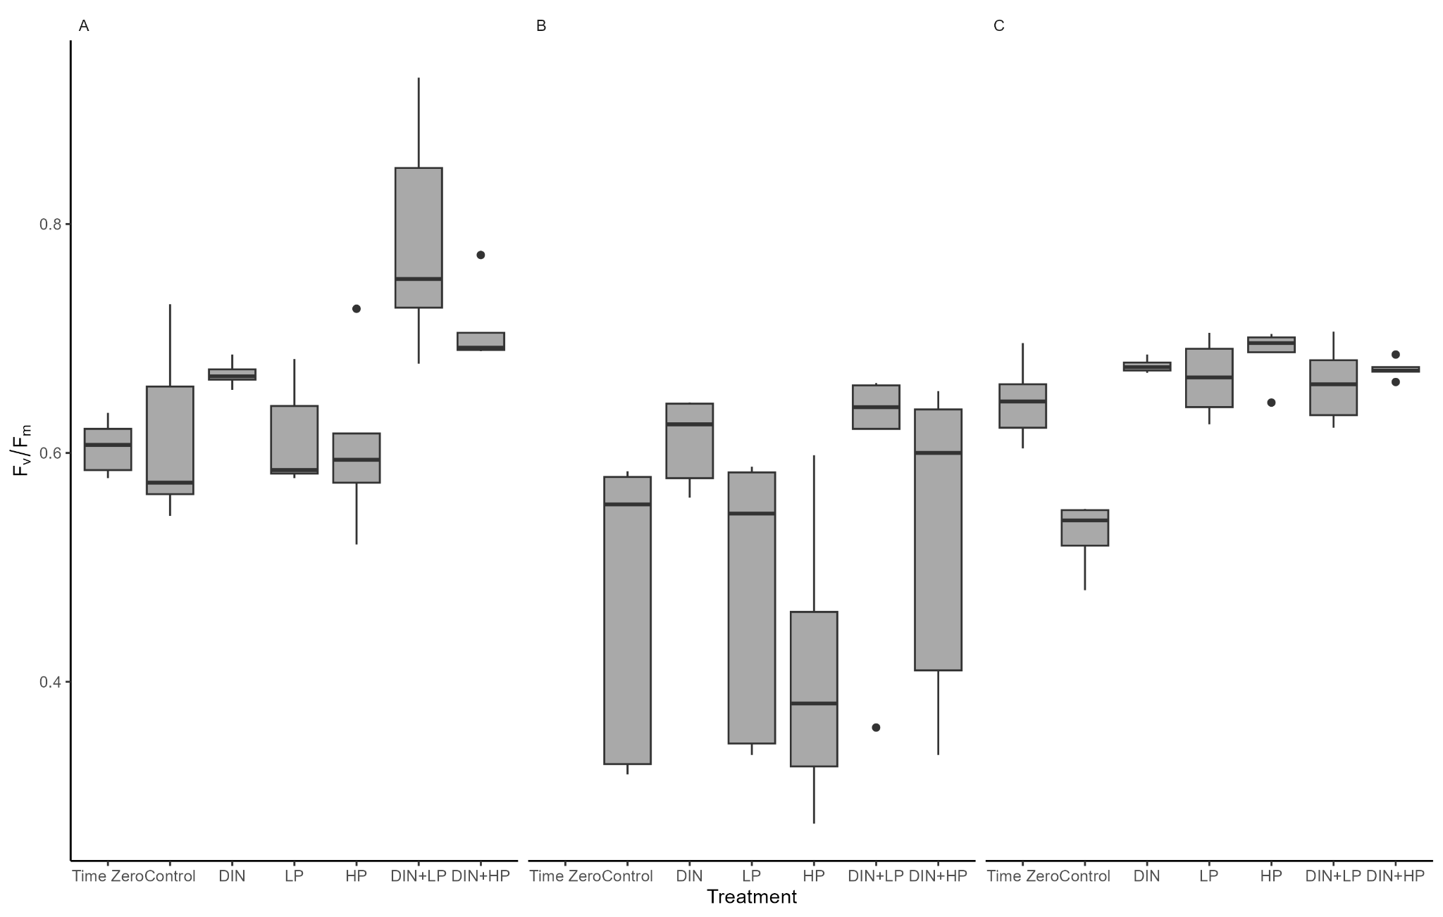

**Figure A2.** Fv/Fm values by treatment groups for the June (A), July (B), and September (C) bioassays. Equipment errors resulted in missing data for the July time zero group. The bold line represents the median, the box edges represent the 25th and 75th percentiles (lower and upper edge, respectively), and the extreme ends of the lines represent the smallest and largest values within 1.5 times the interquartile range below the 25th or above the 75th percentile, respectively. Dots represent values that are 1.5-3 times the interquartile range on either edge of the box.

Values for Fv/Fm ranged from 0.41to 0.79 (Fig. A2). In the June bioassay, there was a difference in Fv/Fm between treatment groups (F = 6.4353, num df = 6, denom df = 28, p = 0.0002387). The DIN + LP group was significantly higher than the time zero measurement (p = 0.0006), control (p = 0.0011), DIN (p = 0.0307), LP (p = 0.008), and HP (p = 0.0002). Fv/Fm was not significantly different between treatments groups for the July bioassay (Fig. A2B). However, there was a similar pattern to the biomass results, with greater values for the DIN and combined DIN+LP and DIN+HP treatments (Fig. A2A, B). For the September bioassay, there was a significant difference between treatment groups (F = 20, num df = 6, denom df = 28, p = 6.13x10-9). Fv/Fm was greater in all nutrient additions compared to the control (p < 0.0001 for each treatment vs. the control), but there was no difference between nutrient additions (Fig. A2C).

While there were no statistically significant differences in quantum efficiency between treatment groups, the June and July bioassays showed patterns of increase in quantum efficiency that mirrored increases in biomass (Fig. X, Y?). The lack of differences between groups could be a sign of balanced growth under nutrient-limited conditions (Moore et al., 2008; Parkhill et al., 2001). It is possible that NI phytoplankton have acclimated or adapted to ambient nutrient conditions and are able to maintain high quantum efficiency regardless of enrichment. In terrestrial plants, the N content of leaves, of which RUBISCO is a significant contributor, is a strong predictor of photosynthetic capability (Sterner & Elser, 2002). The slight, but insignificant, increases in Fv/Fm in N-enriched treatments could be related to the increased availability of N for RUBISCO, an important photosynthetic enzyme.

*Taxonomic Group Responses*

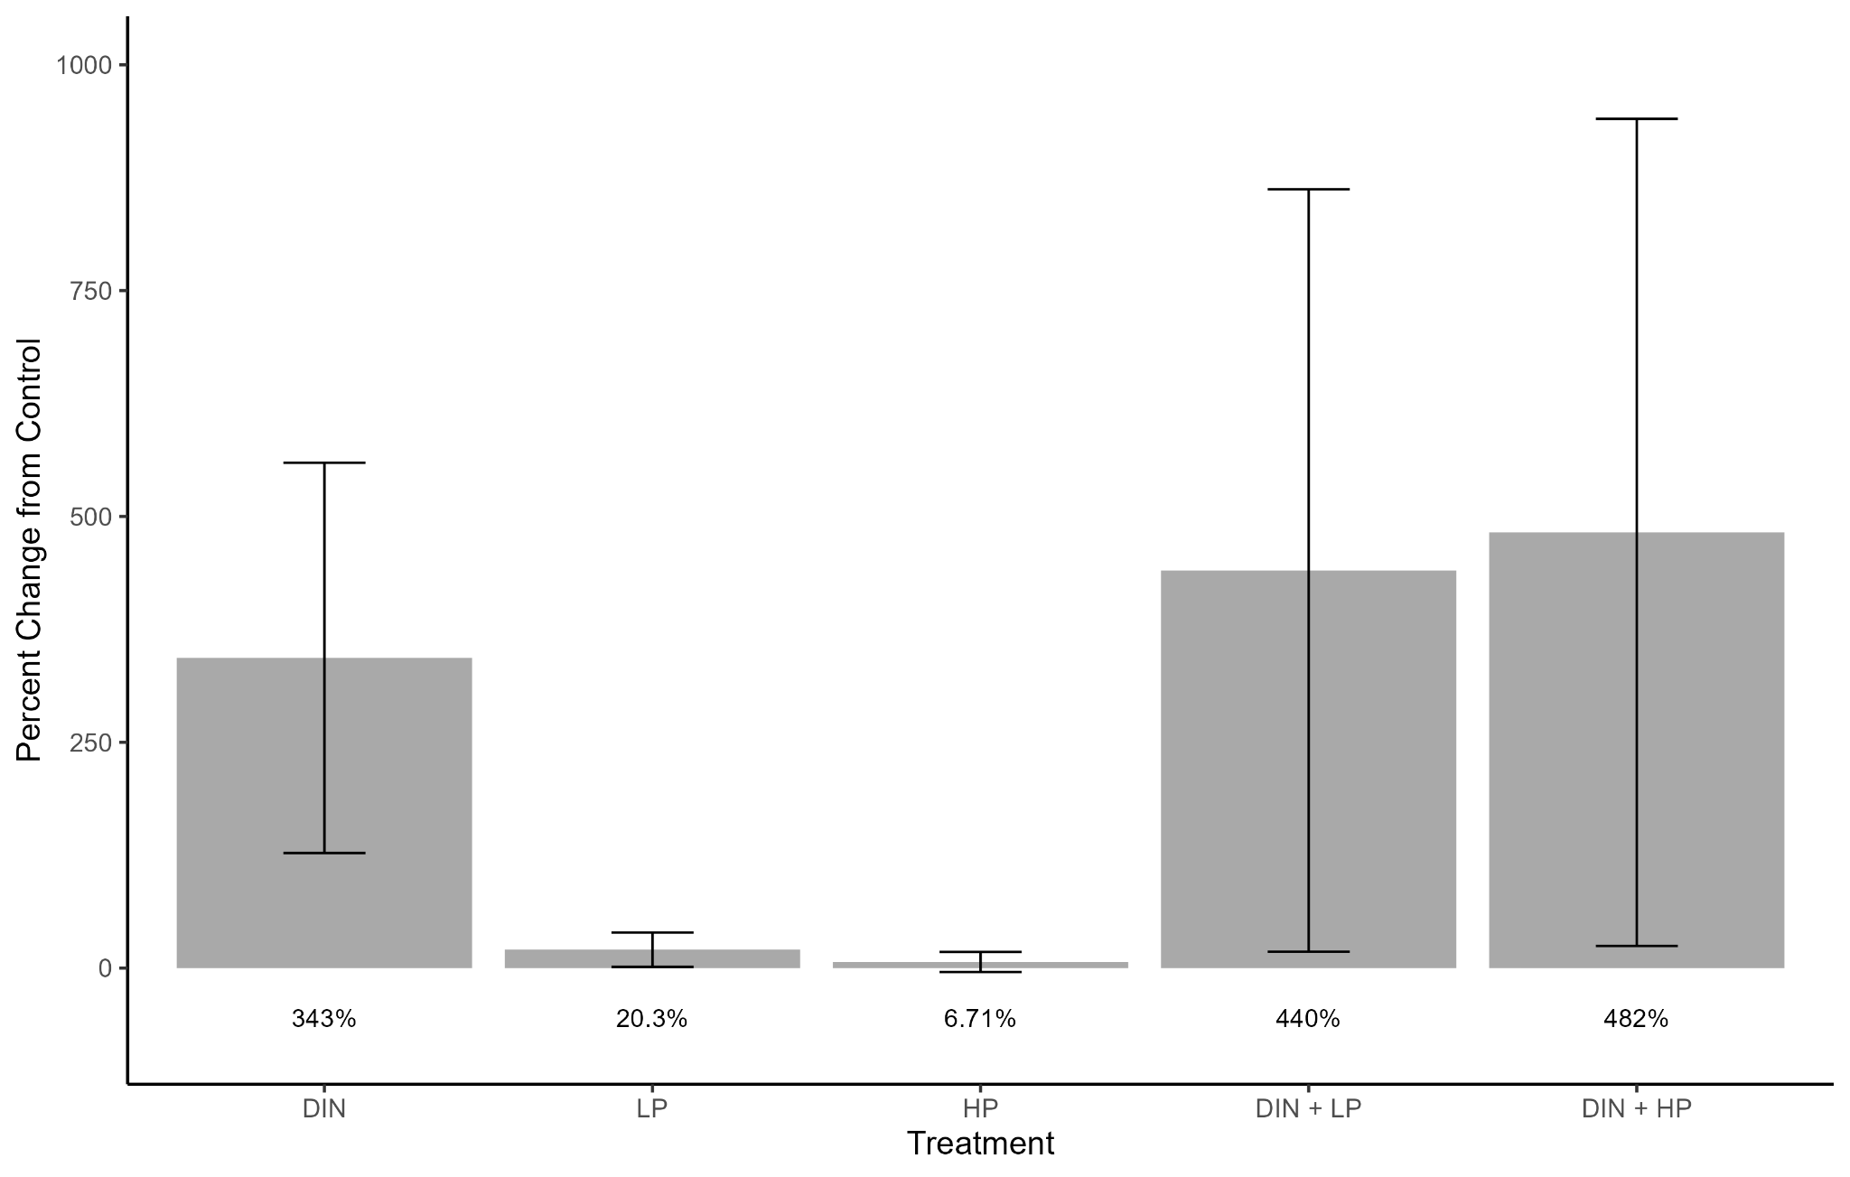

**Figure A3.** Percent change in green algae abundance relative to the control across all bioassays. Error bars represent standard deviation. Mean percent change is displayed below bars. Values were derived from HPLC analysis.

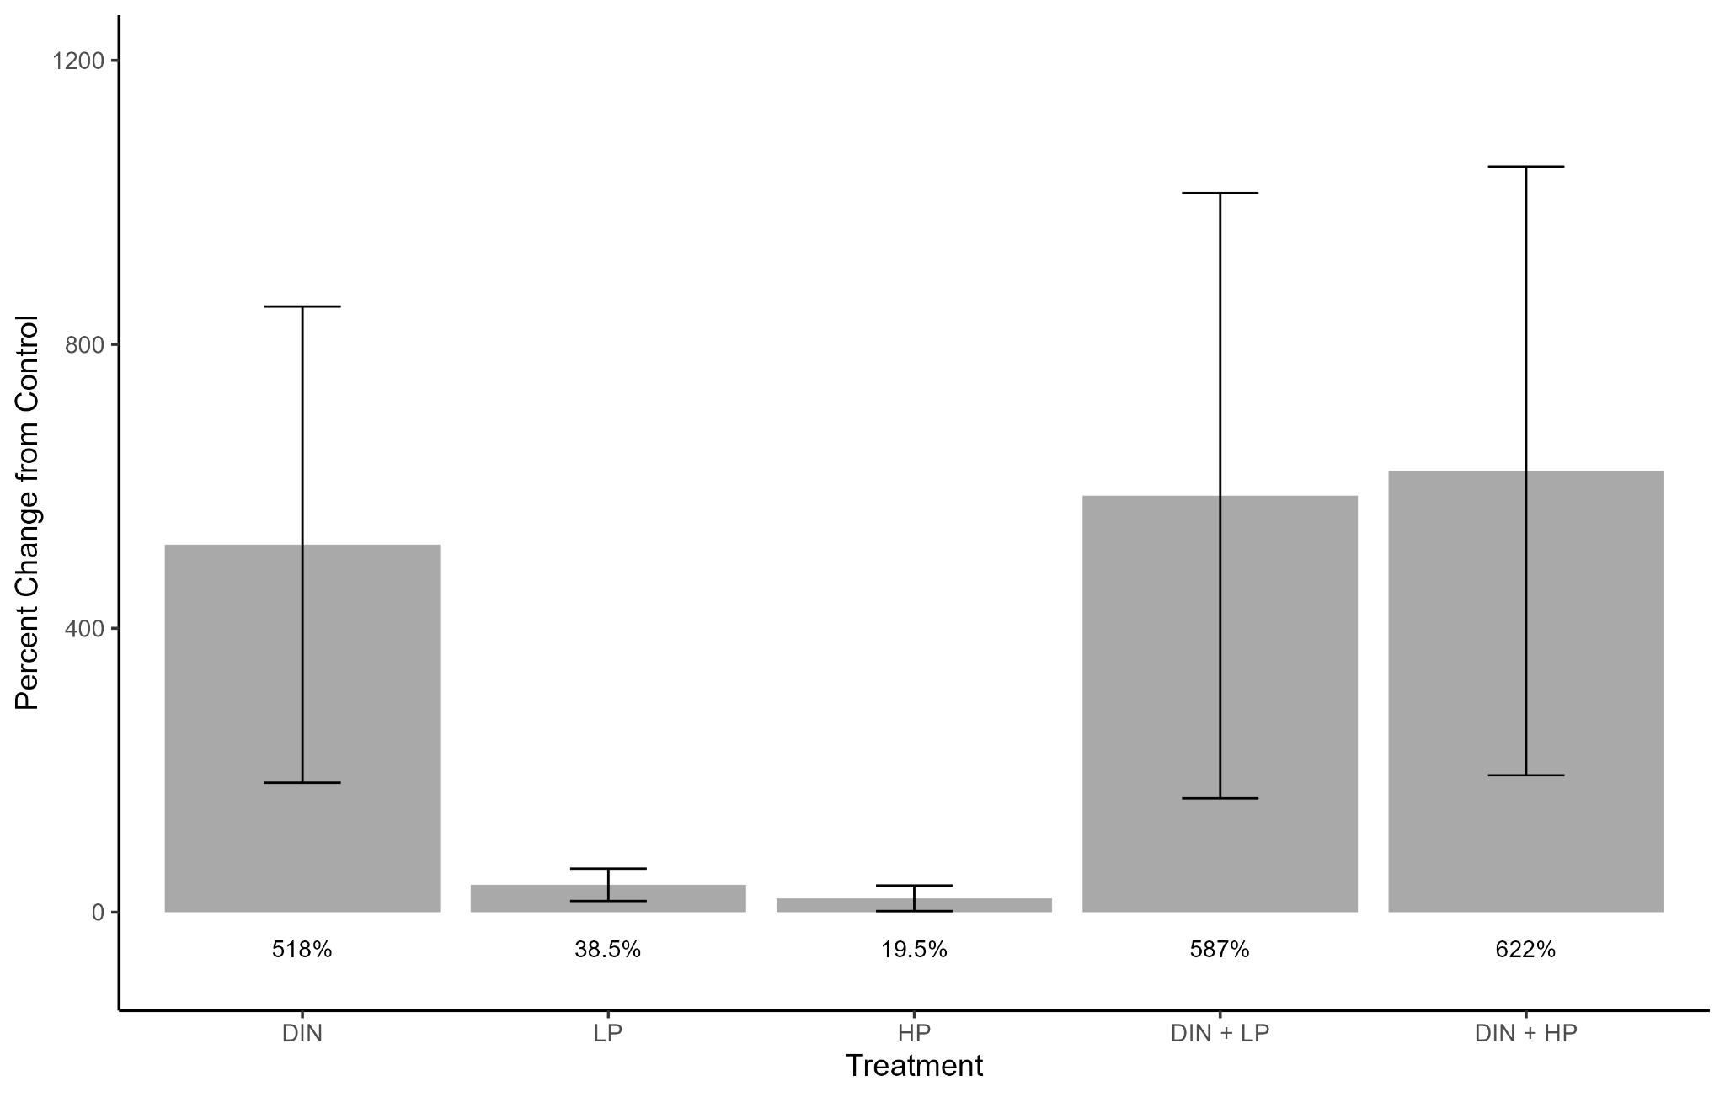

**Figure A4.** Percent change in cryptophyte abundance relative to the control across all bioassays. Error bars represent standard deviation. Mean percent change is displayed below bars. Values were derived from HPLC analysis.

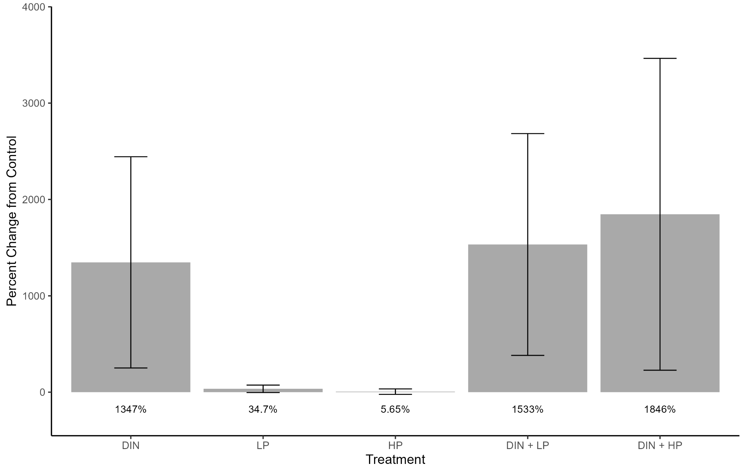

**Figure A5.** Percent change in diatom abundance relative to the control across all bioassays. Error bars represent standard deviation. Mean percent change is displayed below bars. Values were derived from HPLC analysis.

/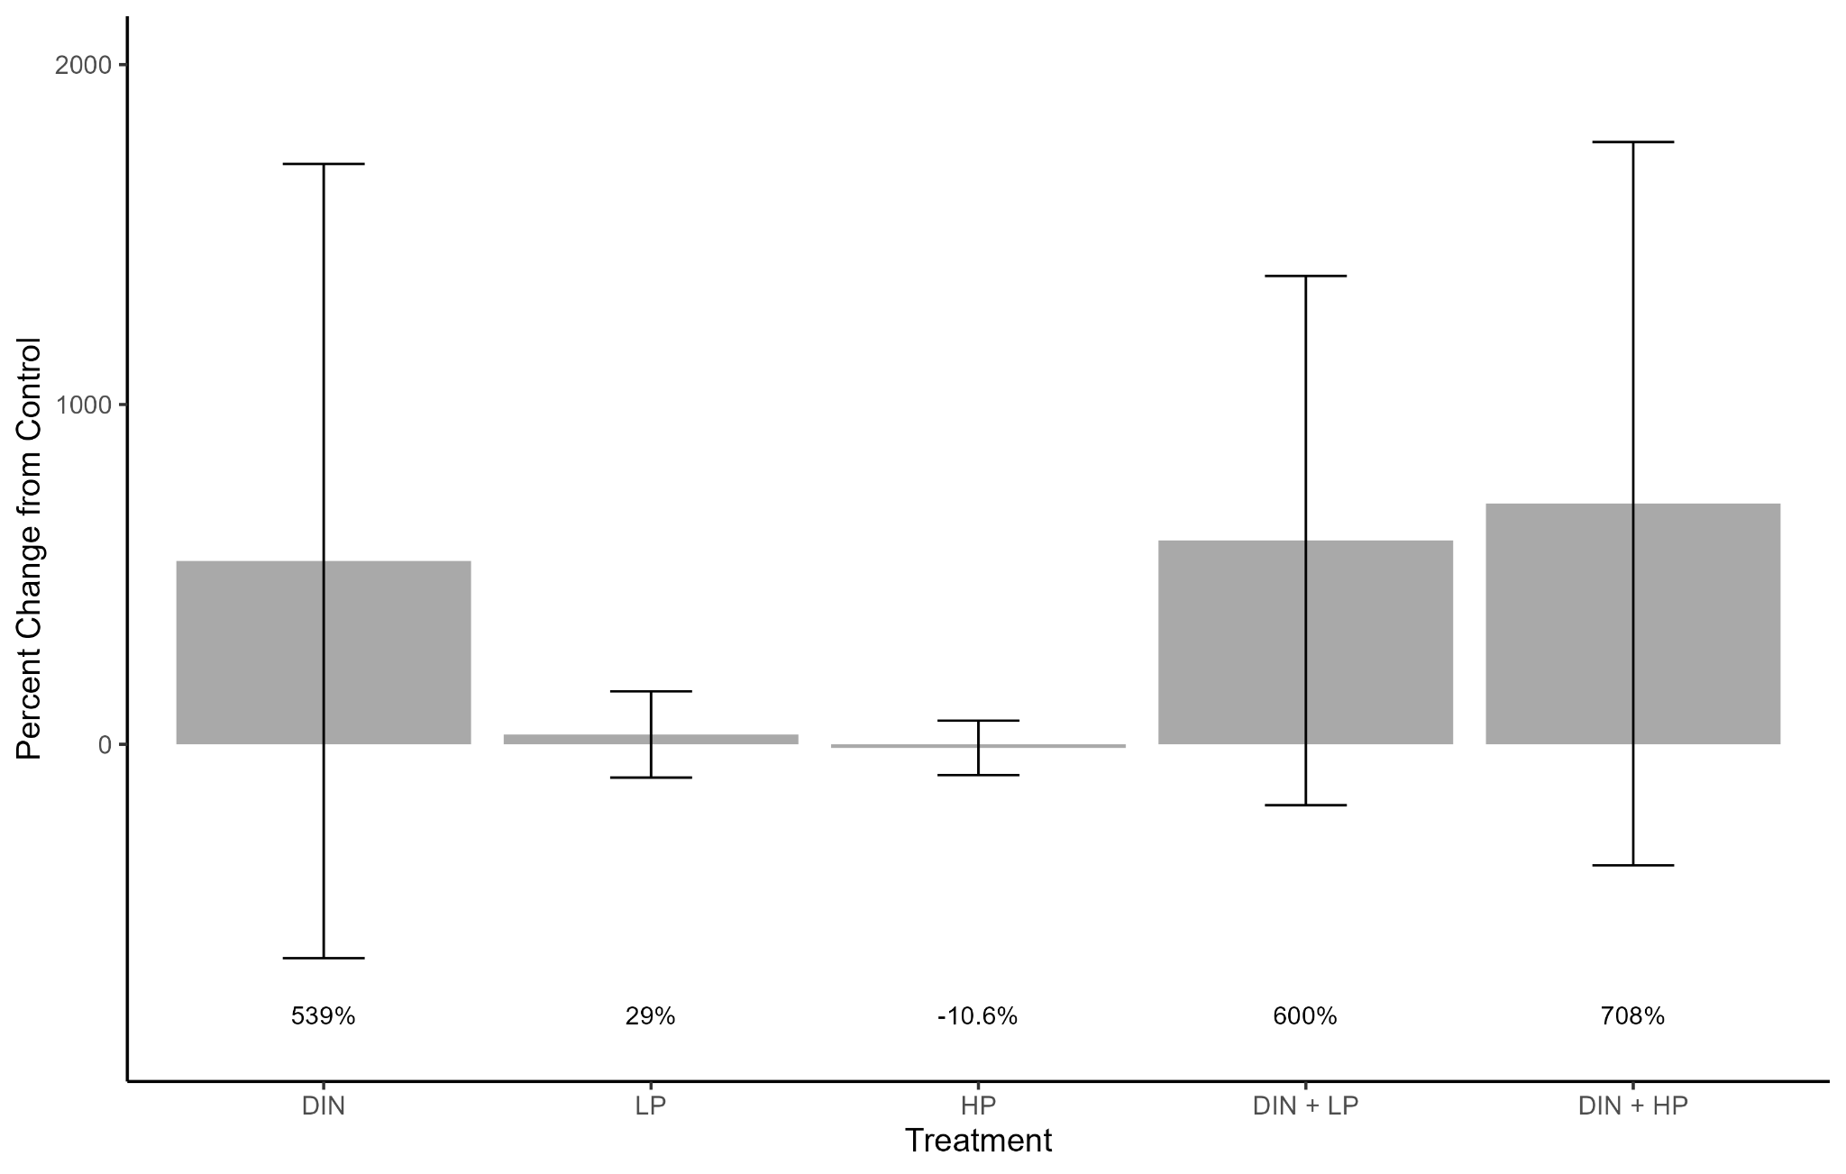

**Figure A6.** Percent change in dinoflagellate abundance relative to the control across all bioassays. Error bars represent standard deviation. Mean percent change is displayed below bars. Values were derived from HPLC analysis.

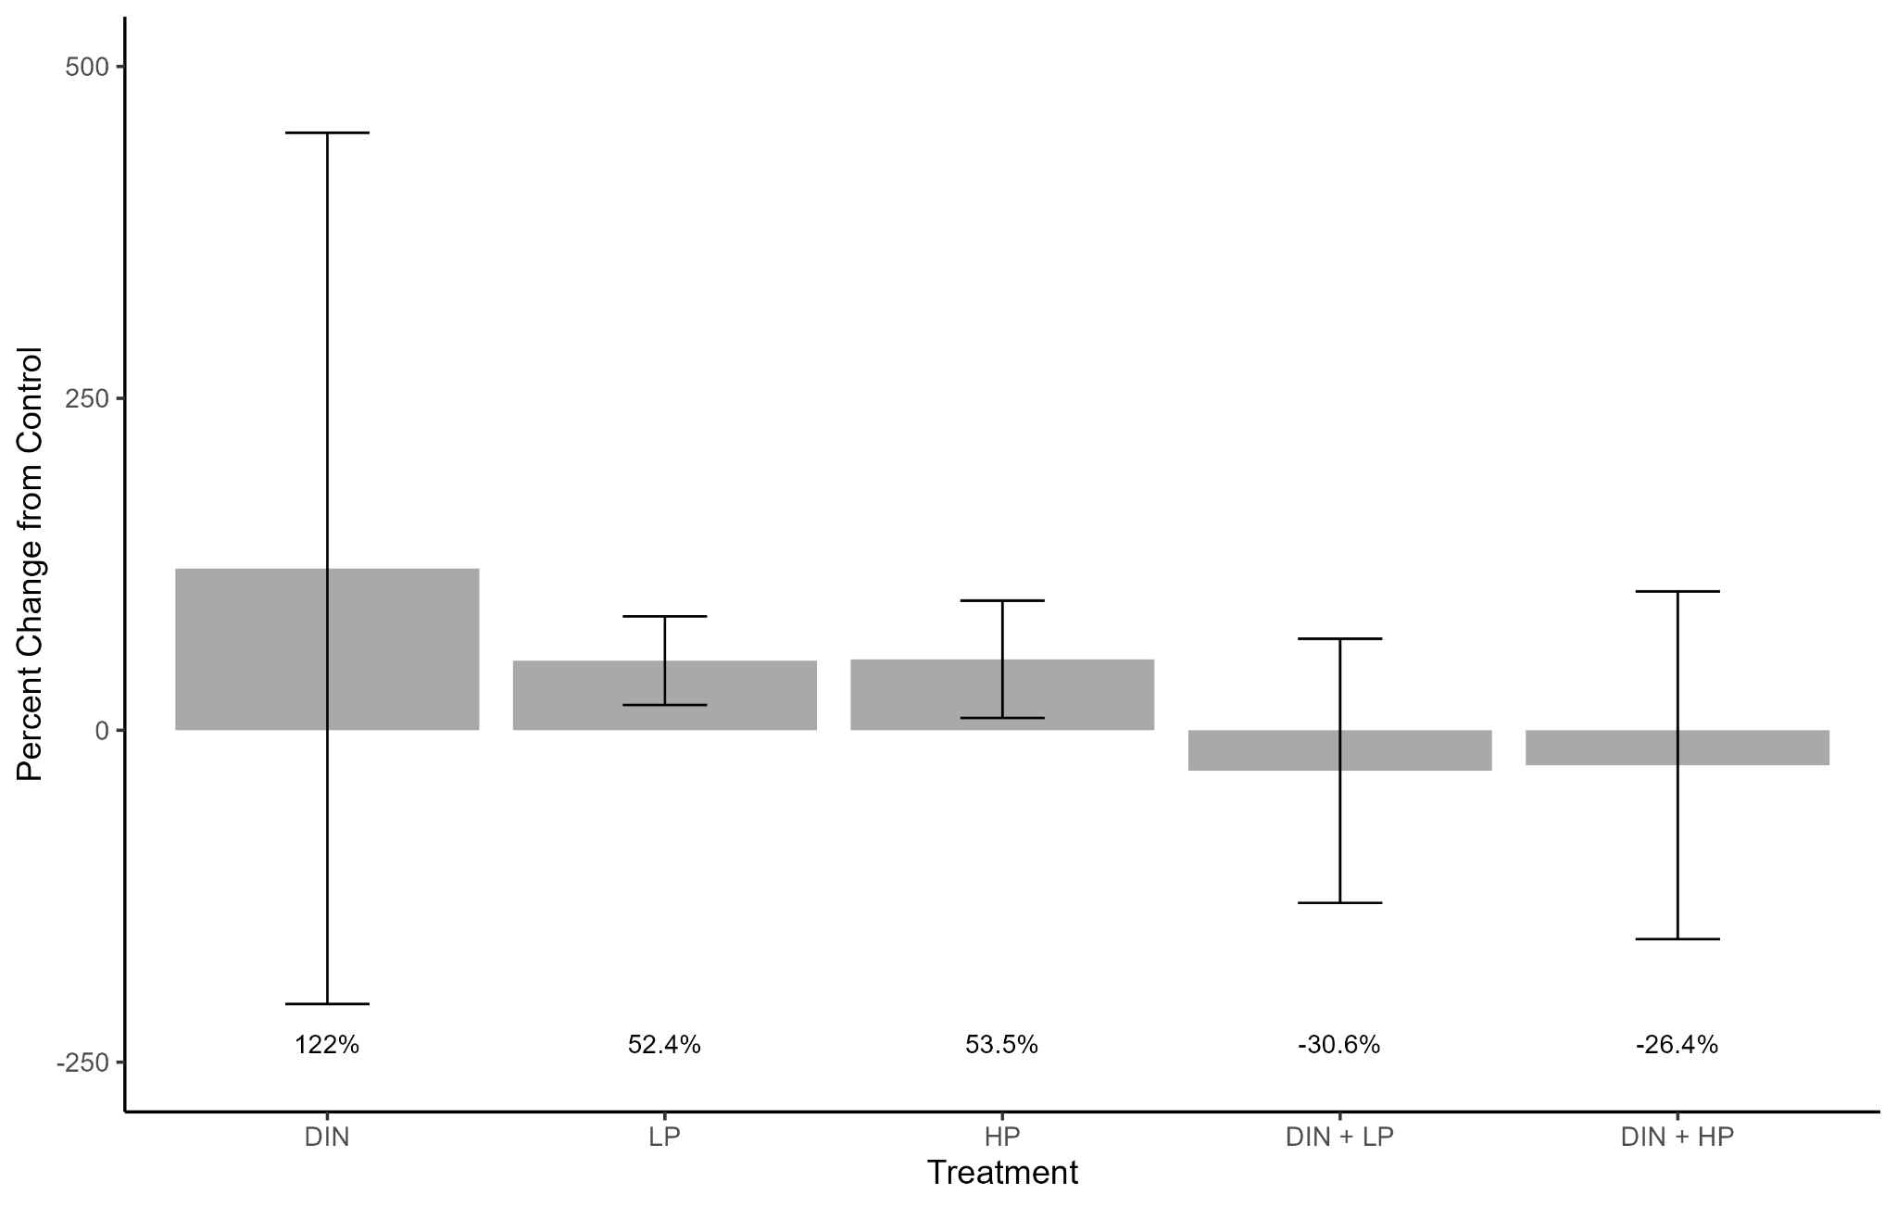

**Figure A7.** Percent change in haptophyte abundance relative to the control across all bioassays. Error bars represent standard deviation. Mean percent change is displayed below bars. Values were derived from HPLC analysis.

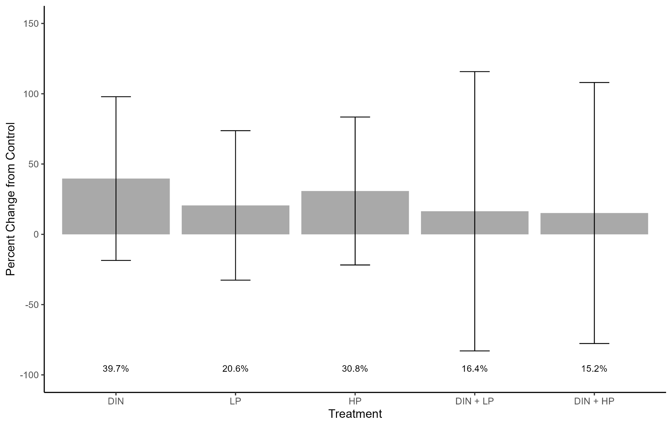

**Figure A8.** Percent change in cyanobacteria abundance relative to the control across all bioassays. Error bars represent standard deviation. Mean percent change is displayed below bars. Values were derived from HPLC analysis.